BS–SIS-1.0.0-001

Effective Date: June 2015

Revision - 1.2

Balloon Observation Platform for Planetary Science (BOPPS) Project

BOPPS InfraRed Camera (BIRC) Instrument Uncalibrated/Calibrated Data Product Software Interface Specification

BS-SIS-1.0.0-100, Rev. 1.2

CM FORWARD

This document is a BOPPS Project controlled document. Changes to this document require prior approval of the BOPPS Program Manager. Proposed changes shall be submitted to the BOPPS Project PM, along with supportive material justifying the proposed change.

Questions or comments concerning this document should be addressed to:

Raymond Espiritu

Email: Raymond.Espiritu@jhuapl.edu

BOPPS Project BIRC Uncalibrated/Calibrated Data Product SIS

SIGNATURE PAGE

Prepared By:

________________________________________ ________________________

Joseph Adams, BOPPS PM Date

________________________________________ ________________________

Andy Cheng, BOPPS PI Date

________________________________________ ________________________

Charles A Hibbitts, BIRC Lead Date

________________________________________ ________________________

Raymond Espiritu, Software Engineer Date

**TABLE OF CONTENTS**

1. **Purpose and Scope 5**
2. **Applicable Documents and Constraints 5**
3. **Data Product Characteristics and Environment 5**
   1. **Instrument Overview 5**
   2. **Data Product Overview 7**
   3. **Data Processing 8**
      1. Data Processing Level 8
      2. Data Product Generation 9
         1. Level 0 Raw Data 9
         2. Level 1 Calibrated Data 9
         3. Level 2 Science Data 10
      3. Data Flow 12
      4. Labeling and Identification 12
   4. **Standards Used in Generating Data Products 18**
      1. PDS Standards 18
      2. Time Standards 18
      3. Data Storage Conventions 19
   5. **Data Validation 19**
   6. **Data Product Structure and Organization 19**
   7. **Data Format Descriptions 19**
      1. **Image Data 19**
      2. **POINTING Data 19**
      3. **RELAY Data 21**
      4. **TEMPERATURE Data 22**
      5. **PTT Data 24**
   8. **Label and Header Descriptions 25**
      1. **Example RAW Science label 25**
      2. **Example BIAS SUBTRACTED label 30**
      3. **Example CALIBRATED label 35**
      4. **Example SHIFTED label 39**
      5. **Example FLATFIELD label 44**
      6. **Example Pointing label 49**
      7. **Example Temperature label 57**
      8. **Example Relay label** 65
      9. **Example PTT label 69**
4. **Applicable Software 75**
5. **Appendices 76**
6. **Purpose and Scope**

The data products described by this Software Interface Specification (SIS) are the BOPPS Infrared Camera (BIRC) uncalibrated and calibrated data products. The BIRC Science Operations Center located at the Johns Hopkins University Applied Physics Laboratory produces these data products and distributes them to the Planetary Data System.

The purpose of this document is to provide users of the data products with a detailed description of the product and a description of how it was generated, including data sources and destinations. The document is intended to provide enough information to enable users to read and understand the data products. The users for whom this document is intended are the scientists who will analyze the data, including those associated with the project and those in the general planetary science community.

1. **Applicable Documents and Guidelines**

This Data Product SIS is consistent with the following Planetary Data System Documents:

1. Planetary Data System Standards Reference, Version 1.3.0, September 18, 2014.
2. PDS4 Data Dictionary – Abridged – Version 1.3.0.1, September 24, 2014.
3. PDS4 Information Model Specification, V.1.3.0.1, September 29, 2014.

# Works Cited

Janesick, J. (2007). Photon Transfer, *SPIE* Volume *PM 170* (ISBN 9780819467225).

1. **Data Product Characteristics and Environment**
   1. **Instrument Overview**

The BOPPS mission was a system development and demonstration to show that balloon-borne scientific payloads can provide a rapid response to a time-critical planetary science opportunity, such as observing and characterizing the volatiles in primitive Oort-cloud comets. In February, 2013, NASA Glenn Research Center, the Johns Hopkins University Applied Physics Laboratory (JHU-APL), and the Southwest Research Institute (SwRI) were directed by NASA to develop a balloon flight for conducting planetary science observations of the comet C/2012 S1 (ISON) that would make a close approach to the earth in early November 2013. This was a fast paced high risk mission that, once developed, would be available to conduct new missions potentially every year – truly a new paradigm in NASA scientific ballooning, especially for conducting high value planetary science ‘Decadal’ measurements not possible from existing ground, air, or space assets. The Balloon Observation Platform for Planetary Science (BOPPS) mission was the second flight of this concept. It launched from Ft. Sumner, NM, at 08:20 on September 25, 2014, ascending to a float altitude of 130,000’. Its mission, to observe multiple comets and asteroids, commenced immediately after verifying the platform was fully operational.

The main objective of BOPPS was to observe one or more comets, with the Oort Cloud Comet, C/2013 A1 (Siding Spring), being of special interest. The BOPPS BIRC instrument had the objective of observing the H2O and CO2 emissions from an Oort Cloud comet at 2.7µm and 4.3µm respectively.

Figure 1 shows the BOPPS gondola frame with the telescope in the stowed position. The gondola is suspended from the structure at the top of the frame, which is referred to as the “penthouse”, so the telescope is pointing up towards the top of the balloon in the stowed position. The underside of the penthouse contains a calibration target. The instrument suite, including the BIRC camera, is mounted underneath the telescope, on the elevation mount cradle. A portion of the sugar scoop baffle is not shown in the figure.

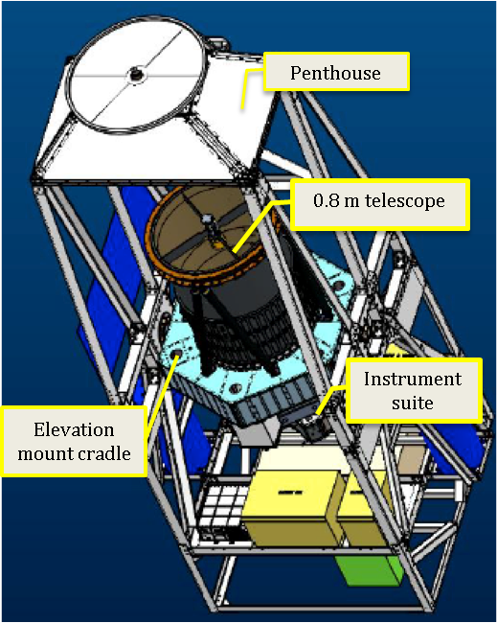

Figure 1 BOPPS Gondola with telescope in stowed position. The elevation mount cradle holds the telescope and the instrument suite. The sugar scoop telescope baffle is not shown.

The payload was carried to an altitude of 40 km – above 99.5% of the Earth’s atmosphere – to observe the comets with an imaging instrument suite composed of two instruments covering the near ultraviolet and visible (UVVis) and mid infra-red (MIR) portions of the electromagnetic spectrum from a gondola that was designed to obtain arcsecond pointing stability over the duration of multiple image acquisitions. The BOPPS UVVIS instrument included a fine steering mirror and guide camera system to demonstrate capability to stabilize the field of view sufficiently that diffraction–limited imaging would be possible on future missions. During the BOPPS flight, UVVis demonstrated this capability with star imaging.

The BOPPS Infrared Camera (BIRC) is a multispectral infrared imager designed to operate in 8 wavelengths between 2.5 and 5.0 μm, with each spectral width being ~ 3% of the center wavelength, and the astronomical R-band near 640 nm. BIRC was designed to measure the water and CO2 emissions from comets at 2.73 and 4.3 μm, respectively, and the water-related infrared absorption feature in asteroids and the Moon from ~ 2.5 to 3.2 μm.

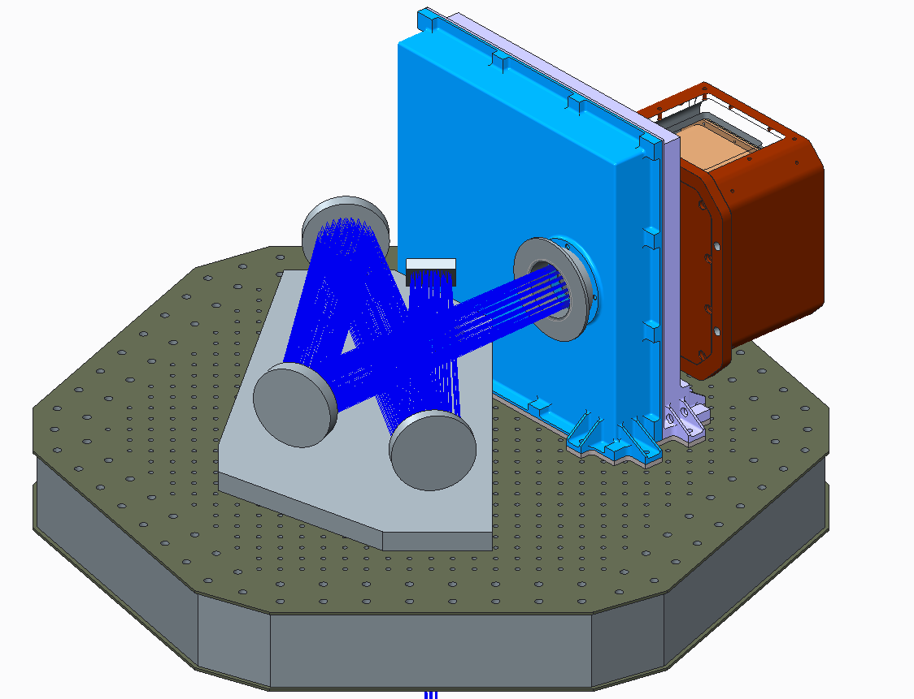

Figure 2 Model of the BIRC instrument showing the fold mirror, aspheric collimating mirror, and the two flat relay lens with the collimated illumination then passing through the filter wheel.

This capability is obtained with a Teledyne H2RG cryocooled HgCdTe detector and an 80cm telescope. The system produces an f/4 image over a field of view of 3 arcminutes, which subtends approximately 151 pixels on the 2K x 2K array, and employs shift/co-add algorithms to increase signal-to-noise for the observation of dim objects. The BIRC is comprised of a collimator subsystem and a camera. The collimator is designed to relay the beam from prime focus of the Ø80 cm main telescope to the camera after passing through the cryogenically cooled nine-position filter wheel. The collimator subsystem consists of an enclosed, cooled, nitrogen-purged box (the “cold box”) with a collimating mirror and three fold mirrors, all of which are coated with protected gold to reduce thermal self-emission. Light enters the cold box through a CaF2 window, and a collimated beam exits the cold box through another CaF2 window. The collimated beam passes through an evacuated, cryogenically cooled nine-position filter wheel and then enters the camera, where the light is focused on the Teledyne H2RG detector by a small Ritchey-Chretien telescope inside the evacuated and cryogenically cooled camera body. The ‘cold box’ is maintained at ~200K to reduce thermal self-emission to well below that which is contributed from the main telescope or from downwelling sky radiation. The spent liquid nitrogen is then used to purge the cold box with dry N2 so that frost does not form on the mirrors when the mission is being prepared for launch on the ground and during ascent. The filter wheel is cooled by liquid nitrogen to 150K or cooler, while the small Ritchey-Chretien telescope inside the camera is cooled by a mechanical cryocooler to ~100K. This cryocooler also maintains the detector at 70K or lower.

Custom firmware provided by Teledyne Imaging Systems allows the BIRC flight software to readout a programmable area of interest, which was then defined to be the central 320 x 200 pixel region that contains the 3 arcmin field of view and additional pixels for dark calibration. It is this subframe that is generated by the BIRC instrument for all the image data. The average plate scale of the detector is 1.1572 arcsec/pixel with a standard deviation of 0.062205 arcsec/pixel. Figure 3 shows the relationship between the full detector array and the subset window the BIRC flight software was reading out.



Figure 2 BIRC detector array and location of image subframe.

* 1. **Data Product Overview**

The SIS describes science and state of health (housekeeping) data acquired by BIRC. Data were acquired on schedule based upon the Design Reference Mission and the time of launch. Science data were acquired at a variable rate depending on the commanded integration time which was sent in either real-time or as part of a commanded script that was executed by the BIRC flight software. The science data are sorted by observation, filter wheel and integration time. Housekeeping data are separated into three product types: temperatures, relays, and pointing information. Temperature and relay data were acquired at a set rate of 0.1Hz. Pointing data were generated at a rate of 20Hz. All housekeeping data are stored in ASCII files ordered by time and containing 1 hour’s worth of data per file. The specific data products described by this SIS are:

1. RAW Science Data – These data are reconstructed from telemetry and include time of observation, instrument temperature and pointing information, and the BIRC image in DN. Each FITS file represents a single image frame generated by BIRC.
2. BIAS SUBTRACTED Data – The BIRC camera always generates a bias frame at 3.48 ms integration time with every signal frame at the commanded integration time. The raw images are biased such that larger DN indicates a lower signal strength. Subtracting the signal frame from the bias frame (instead of visa versa) removes the bias contribution to the signal and inverts the DN values such that larger DN now indicates higher signal strength. No further processing is done for this product type.
3. CALIBRATED Data – These data include both partially calibrated and fully calibrated image data. Both partially and fully calibrated image data are median filtered and flat fielded to remove popcorn noise and fixed pattern noise, respectively. Fully calibrated data are further processed by applying an algorithm to convert pixel values in DN to electrons. Partially calibrated data do not have the DN to electron conversion applied.
4. SHIFTED Data – These are image data that have utilized pointing information to shift their pixel positions relative to each other so the observed targets overlap to a subpixel accuracy. Shifting is applied IF the pointing information from the IMU indicates that the telescope pointing has shifted by ~> ½ pixel during an observation. The shifted images are then coadded and averaged.
5. COADDED Data. If the pointing is stable, images are coadded without shifting. After coadding the images, an averaged image is produced. Averaging is done by dividing the value at each pixel position by the number of images that have a valid pixel at that position. For images that were only coadded this is simply the number of images that were coadded. For shifted and then co-added images, a separate index image is created, which keeps a tally of the number of images with valid pixels at a given pixel location. The shifted and coadded image is then divided by the index map to create an averaged image over the entire 320 x 200 image array. For data analysis the illuminated portion of the detector is defined to be within a circle with a center at x=173, y=98 and a diameter of 145 pixels, where x=0, y=0 are at the upper left corner of the image. This diameter is smaller than the measured diameter of 151 pixels and chosen such that small shifts of the telescope would still result in the coadded image having valid pixels within this region. The index image approach was used to produce averaged pixel values in every location of the 320 x 200 image array.
6. FLATFIELD Data – These are images created from coadding bias subtracted data of a uniform field (such as ‘sky’) that have also been median filtered to remove “hot”, or highly variable, pixels as well as randomly active pixels or “popcorn” noise. The coadded image is then normalized to the median value within the 3 arcmin field of view.
7. Pointing Data – These data consist of ASCII fixed-width tables that contain the pointing information generated by the gondola and sent to the BIRC instrument computer to be stored and downloaded.
8. Temperature Data – These data consist of ASCII fixed-width tables that contain temperature values reported by sensors in the BIRC instrument, converted from DN to engineering values.
9. Relay Data – These data consist of ASCII fixed-width tables that contain information on various relay states and the cryo-cooler pressure.
10. PTT Data – These data consist of ASCII fixed-width tables that contain the photon transfer test (PTT) results. The PTT data are used to generate the algorithm that converts DN to electrons. See Appendix A for further details on the photon transfer test.
    * 1. **Image Product Overview**

This section provides information about the point spread function (PSF) in the image data and explains why some of the images contain a non-uniform PSF. Examples of PSF obtained during ground calibration, when atmospheric torque was negligible or non-existent, are shown here and contrasted with examples where telescope slew or pointing jitter would result in images containing a non-uniform PSF. These non-uniform PSF images could not be corrected in post-flight processing but for the sake of completeness are included in the PDS archive.

Figure 4 shows the PSF at different stages during ground calibration. Figure 4a shows a FWHM of 2 pixels for the camera assembly alone - the window, filter wheel, and RC re-focusing optics. Figure 4b shows a PSF of approximately 3.5 pixels after the collimator was assembled and integrated with the camera, with nitrogen purge and cryocooler operational. Finally, Figure 4c shows a PSF of 4 pixels with a fully integrated optical system during a “hang test”, where the gondola was suspended from a crane, free to rotate, while the payload observed the night sky.

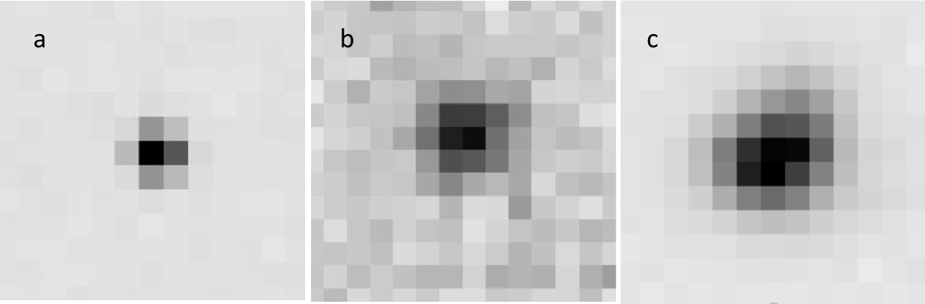

Figure 3 Images of point sources from ground test.

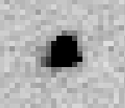The following figure shows a typical PSF (4 pixels) for a BOPPS calibrated image obtained during flight. The image shows the calibration star HD196724 for Comet Jacques in R-band. There is negligible pointing jitter and the telescope is not being slewed. This is an example of an image that can be used in data analysis.

Figure 4 Image of HD196724 from flight.

The torque applied by the upper atmospheric winds on the telescope and gondola coupled with the inherent drift in the gryoscope pointing accuracy would sometimes combine to generate targets with a non-uniform point spread function. The telescope pointing software and gondola guidance system were designed to counteract this torque. However, the targets in some image data sets were still shown to have a non-uniform PSF due to platform pointing jitter and drift. Cumulative effects of jitter and drift become very apparent when individual images are shifted and coadded using pointing data supplied by the gondola, as the pointing data do not account for drift or jitter. This results in a ‘blurred’ effect as the target is smeared across several pixels due to its apparent motion across the camera FOV. Figure 6 shows an example of a blurred image taken from the shift and coadd data product for cal star HD133772.



Figure 5 Blurred Shift and Coadd image resulting from pointing jitter in individual source images

A final source of “blurred” images results from BIRC observations taken while the telescope is being slewed. Operation of the BIRC camera is decoupled from slew commands sent to the telescope and gondola, such that coordination between the BIRC and gondola operators is required to prevent instances where images are generated while the telescope is being slewed. Unfortunately, since both telescope slew changes and BIRC image generation were done manually there were several instances where images were unintentionally generated while the telescope was in motion. Conversely, observations during telescope slew were standard procedure during real-time sky searches of the target, as the BIRC camera was required to generate images while the telescope was slewing in order to center the target in the camera field of view. For this reason it is not recommended to use images designated as “real-time” or “search attempt” in the `observation type` section of the filename for photometry or spectral analysis. See Table 5 for a list of file name prefixes versus observation type.

The following example is a BIRC image taken while the telescope was being slewed. This was done during a real-time search of calibration star HD163761 in order to acquire the target and center it in the BIRC FOV.

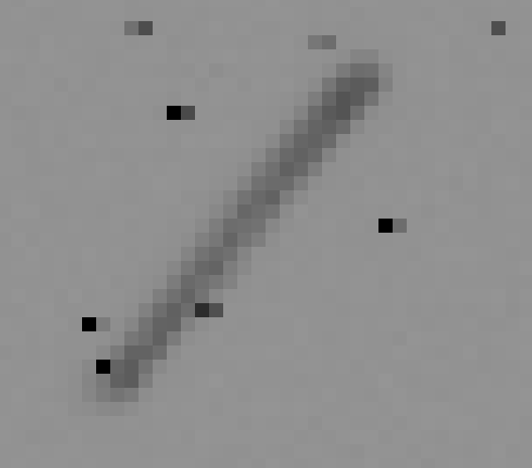

Figure 6 BIRC image of star HD163761 during real-time search

**Your Text Here**a

* 1. **Data Processing**

This section provides information about the data product content and data product generation.

* + 1. **Data Processing Level**

The following table describes each data product in terms of its NASA and/or CODMAC processing levels

|  |  |  |
| --- | --- | --- |
| BIRC Product | NASA Product Level | Description |
| RAW | Level-0 | Individual raw BIRC image frames |
| BIAS SUBTRACTED | Level-0 | Image created from a subtraction of the signal frame from the bias frame |
| TEMPERATURE | Level-1 | Temperature data reported by the BIRC instrument |
| RELAY | Level-1 | Relay data reported by the BIRC instrument. |
| POINTING | Level-1 | Telescope pointing information reported by the gondola. |
| CALIBRATED (DN) | Level-1 | Filtering and flat field applied to bias subtracted image |
| CALIBRATED (e) | Level-1 | As above, with pixel values converted to units of electrons |
| PTT | Level-1 | Photon transfer test results utilizing the ground calibration image data. |
| SHIFTED | Level-2 | Single image product result of shifted and coadded calibrated images |
| COADDED | Level-2 | Single image product result of coadded calibrated images. |
| FLATFIELD | Level-2 | Single image product result of coadded, filtered, bias subtracted images of a uniform field of view, which is then normalized by the mean of the field of view of the averaged result |

* + 1. **Data Product Generation** 
       1. **Level-0 Raw Data**

The following steps describe the creation of the RAW and BIAS SUBTRACTED Level-0 image products. The processing of BIRC data is conceptually straightforward. The steps to go from a BIRC telemetry file (.bin) to Level-0 images are:

* Separate the images from the pointing and status information. The status information includes the relay and temperature data. The status information is saved in binary table format for further processing later in the pipeline. Eaßch telemetry file may contain several images stored as 12-bit packed integer data.
* Loop through the images and decompress the image data from a 320 x 200 12-bit packed pixel image subframe to a 320 x 200 16-bit integer array. This array is then written to a FITS file. This becomes the RAW Level-0 product.
* Collate bias and signal frame pairs and for each pair subtract the signal frame from the bias frame and then write the array to a FITS file. The signal is subtracted from the bias because photoelectrons generated in the detector DECREASE the bias so that signal results in a reduction of the data values.. This difference image becomes the BIAS_SUBTRACTED product. Note, the detector integrates while reading, and therefore a ‘bias’ frame has the minimum possible integration time of 3.48 milliseconds. This 3.48 ms is also the time increment by which the integration time can be changed, so that the integration time for a bias subtracted image equals (N-1) * 3.48 ms.

Figure 8 shows an example of a bias-subtracted image, which is also representative of a calibrated image with the exception that the calibrated image values are in electrons instead of DN. Four rows at the top and four rows at the bottom are masked regions of the array. The exposed region is usually apparent as a circular field of view and corresponds to the area of illumination as determined by the field stop. For single images the illuminated region is defined with the center at x=173, y=98 and a diameter of 151 pixels, where x=0, y=0 are at the upper left corner of the image. All pixels outside this region are not used for data analysis as they are outside the illuminated portion of the detector. Note that this is the same center used to define the illuminated portion of the detector for the coadded data products. The only difference is that the coadded products have an artificial diameter of a 145 pixels imposed in order that small shifts of the telescope pointing would still result in the coadded image having valid pixels within this region.

Image artifacts outside the exposed region are due to scattered light in the detector. At certain wavelengths the exposed region may not be readily apparent and the image may appear to have a rectangular field of view with reasonable pixel values over the whole image. However, this is not the case and all filters can be considered to have the same field of view. The circular field of view defined above should be used for any data analysis for all filters.

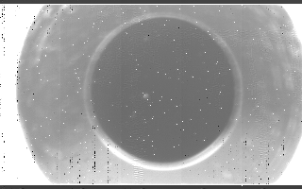

Exposed Region

151 pixels

Masked Region

Masked Region

Figure 8 Example Fits image

* + - 1. **Level-1 Calibrated Science and SoH data**

The State of Health data are stored as level 1 data products with values in physical or engineering units. Level-0 image products are converted to Level-1 image products and are either partially calibrated (still in DN), or fully calibrated with values in physical units.

Partially calibrated data with images in DN only apply in the case of images taken during ground calibration. The purpose of the ground calibration altitude chamber test was to characterize the detector response at varying signal levels and develop an algorithm for conversion from DN to electrons – ie. conduct a photon transfer test. Since the images themselves were used to determine the algorithm, archiving Level-1 ground calibration images in units of electrons would not be useful for further calibration analysis.

For all calibrated image data products the first step was to remove pixel noise in individual BIAS SUBTRACTED images by using a spatial filter to identify “hot” pixels (pixels that remain at high signal throughout multiple images) and replace them by the median value of a 3x3 pixel region centered on the hot pixel. The next step was to apply a flat field (also in DN) to each image to remove fixed-pattern noise. ‘Popcorn noise’, or pixels that turn on and off between images, were also identified and similarly replaced with a median of their surrounding pixels. For ground calibration images this results in the CALIBRATED product with pixel values in DN. For images taken during flight the DN- to-electron conversion algorithm is applied, and the images are saved as the CALIBRATED product with pixel values in electrons.

* + - 1. **Level-2 Science**

The Level-2 Science data include the SHIFTED, COADDED, and FLATFIELD data products. To generate a SHIFTED data product, CALIBRATED products associated with a given observation, filter, and integration time are collated in time order, as is pointing information consisting of the instantaneous shift up/down and left/right in arcseconds required to point the telescope boresight to the target. First order interpolation is used on the pointing records in order to get an estimate of telescope position for each image. A 2x2 rotation matrix is then used to transform the instantaneous shift values into row, column shifts in the image reference frame. The shift matrix corrects for changes in the pointing of the boresight and not for any rotation angle around the boresight (the latter is controlled by an anti-pendulation flywheel on the gondola). The pipeline software then calculated the row, column image shifts with respect to the first image taken in the image set, shifted successive images with respect to the first, and added all images together.

If the target is too dim to be detected in an individual image, it is necessary to coadd a number of images before the target can be detected in order to make an assessment of whether any appreciable pointing shift has occurred. In such cases, the initial image set was divided into subsets (an equal number of images in each subset), and a shifted and co-added image was generated for each subset. If the subsequent shifted and coadded images still showed a drift over ~3 pixels then the image set was further subdivided, until the smear was reduced to less than 3 pixels.

For images taken with the CO2 filters (3 and 4), where the SNR was very small, and data were taken over several minutes, the inherent drift rate of the pointing system was utilized to identify and isolate the target. This was done by subdividing the image set into several subsets, shifting and co-adding each subset, then combining the shifted images into an animated gif. The target was then identified since it was the only source in the image that moved in the same direction at a constant rate during the animation.

A shift set number is included in the SHIFTED product file naming convention to identify cases where multiple SHIFTED products were created for a given observation. The shift set number is set to 0 for cases where only one SHIFTED product was created for an observation. The shift set number starts at 1 and goes to N, where N is the total number of shifted products created for an observation.

The COADDED data product is generated by collating CALIBRATED data products associated with a given observation, filter, and integration time in time order, co-adding them, and dividing by the number of images to get an averaged result.

The FLATFIELD data product is generated by collating BIAS SUBTRACTED data products associated with a given observation of a uniform field of view, filter, and integration time in time order. The software then removed hot pixels and popcorn noise. The filtered images are then co-added, divided by the number of images co-added, and normalized using the mean value of the averaged image in the 3 arcmin field of view. The FLATFIELD product is used in the generation of the CALIBRATED products.

For observations conducted on targets during flight there were usually two sets of observations done per target, designated set A and set B. The object was offset in the field of view between these two sets. Set A was the initial observation of the target with the telescope pointed to the commanded target location in RA and DEC. Set B was taken with the telescope shifted by XX arcseconds (“nodded”) in elevation resulting in the target located in a different part of the image. Images from set A were then used to create the FLATFIELD products for use in generating Level-1 and Level-2 products for set B, and vice versa. Each of the targets was observed as slightly extended; the magnitude of the A-B nod was much greater than the angular extent of each source. The region of the target in set A is bland and featureless in set B, so that set B images are used to generate the flat field for the set A images of a target, and set A gives the flat field for set B.

The source is not removed from the flatfields, leaving a positive feature at the source position which is not masked out. When the flatfield is used for the generation of the FLATFIELD product, this feature creates a “dark target” image which is a negative image of the source in the flatfield image. The FLATFIELD image is used to correct the region around the source in SHIFTED and COADDED products, in which the source location is well separated from the dark target in the flatfield image.

Figure 9 shows an example of a SHIFTED image product. The image has been flatfielded with coadded images from Set B, after the telescope has been nodded 30 arcseconds. Since the target was not masked in the generation of the flatfield an artificial dark target was created when the flatfield was applied to the shifted images. This is also an example of the case where the filter and integration time resulted in an image where the exposed region (the illuminated portion of the detector) is not readily apparent.

Shifted and coadded products and their associated calibrated images were only created in cases where the 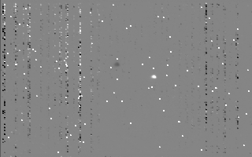target could be detected. However, raw and bias-subtracted products were created from the entire set of images collected, in case future refinement and data calibration results in target detection. The following figure shows the targets and filters in which they were detected.

Dark target

Ceres 1 target

Figure 9 Example SHIFTED image, Ceres 1 in R-band

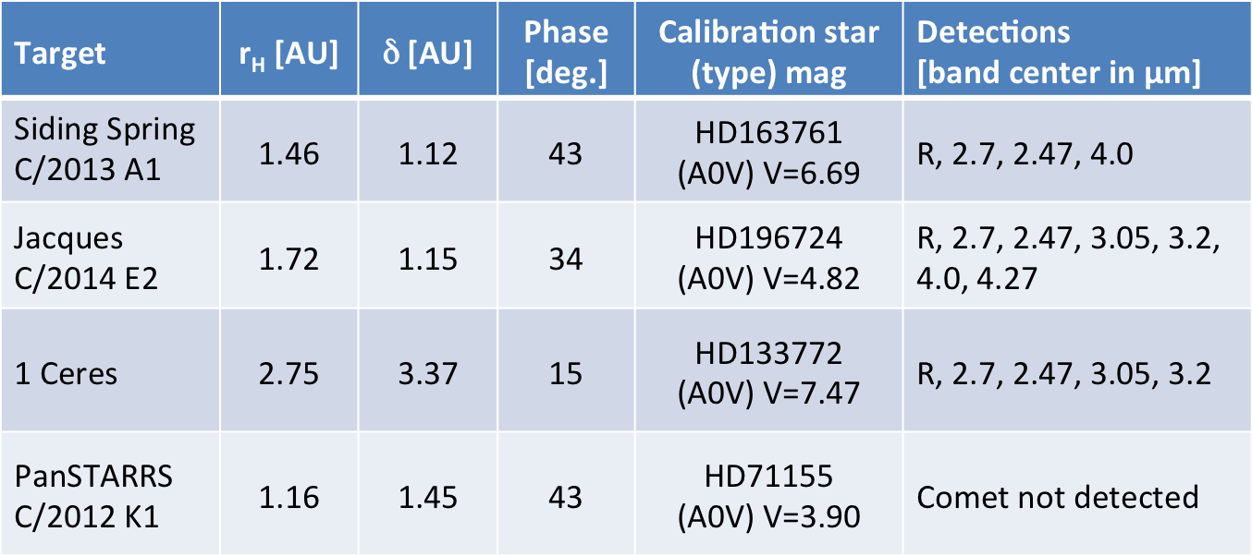

Figure 7 Target Detection Table

For results of the photon transfer test (ground calibration) see Appendix A. The Level-0 through Level-2 ground calibration products are contained in the Calibration collection.

* + 1. **Data Flow**

BIRC data products are built up in sequential processing steps addressing specific calibrations. All data products are built from raw telemetry that was stored on-board in the BIRC instrument and downloaded post-mission.

* + 1. **Labeling and Identification**

**Level 0 – 1 Image data**

A single FITS file represents a single image frame (for RAW data) or an image pair (for BIAS SUBTRACTED or CALIBRATED data). The file naming convention for RAW, BIAS SUBTRACTED, and CALIBRATED image data is:

obsd_n_hhmmssMSC_F###_YYYYt.ext

obsd – 4 character string identifying the type of observation. See table 5 for a short description of each of the observation types identified

n – single digit indicating filter used. See table 6 for a list of filter number vs. wavelength

hhmmssMSC – hour, minute, second, millisecond in UTC associated with the read time of the image. For BIAS SUBTRACTED and CALIBRATED data, which are the result of a bias-signal image pair, the read time of the signal frame is used.

F### - the three digit temperature recorded by the window 1 sensor in degrees C rounded to the nearest whole degree. The ‘F’ is either the character ‘p’ or ‘n’ depending on whether the temperature is a positive or negative value.

YYYY – the four digit integration time of the image in milliseconds, rounded to the nearest millisecond.

t – single character indicating the product type:

r – RAW

b – BIAS SUBTRACTED

d – CALIBRATED with pixels in DN

e – CALIBRATED with pixels in units of electrons

.ext is a three character file extension. Either ‘fit’ for the FITS file or ‘xml’ for the PDS4 XML label.

**Level-1 State of Health Data**

A single Level-1 SOH product contains an ASCII fixed-width table containing one hour of data. The file naming convention for RELAY, TEMPERATURE, and POINTING data is:

yyyy_mmdd_hhmmss_obsd_t.ext

yyyy_mmdd– four digit year, two digit month, two digit day of month corresponding to the timetag of the first record converted to UTC

hhmmss – two digit hour, two digit minute, two digit second corresponding to the timetag of the first record converted to UTC

obsd – 4 character string identifying the type of observation. See table 5 for a short description of each of the observation types identified

t – single character indicating the product type:

r – RELAYS

t – TEMPERATURE

p – POINTING

.ext is a three character file extension. Either ‘tab’ for the ASCII fixed-width table file or ‘xml’ for the PDS4 XML label.

**Level-2 Image Data**

A single FITS file represents the result of shifting and/or coadding several images. The file naming convention for SHIFTED, COADDED, and FLATFIELD data is:

obsd_x_n_hhmmss_t_YYYY.ext

obsd – 4 character string identifying the type of observation. See table 5 for a short description of each of the observation types identified

x – a digit identifying the shift subset number. Used during observations where the pointing information was insufficient to prevent “smear” due to the target drift in successive images. For these observations the images were further subdivided to mitigate the target smear. This resulted in two or more shifted products for a given observation. Set to 0 for cases where the target drift was negligible.

n – single digit indicating filter used. See table 6 for a list of filter number vs. wavelength

hhmmss – two digit hour, two digit minute, two digit second corresponding to the timetag of the first image in the set of images used to generate the product.

t – product type

s – shifted and co-added

c – coadded

f – flat field. Normalized co-added image

.ext is a three character file extension. Either ‘fit’ for the FITS file or ‘xml’ for the PDS4 XML label. An additional reference file ending in ‘txt’ is also created and is referenced by the XML label. This reference file contains the set of images that were used to generate the Level-2 image product.

**Level-1 Photon Transfer Test (PTT)**

A single PTT product contains the results of the photon transfer test executed on 10 consecutive sets of ground calibration data, where a single set is defined as all the images generated by a single image generation script.

The file naming convention is:

ptt_setMM_setNN.ext

MM – two digit number indicating starting set included in table of results.

NN - two digit number indicating ending set included in table of results.

.ext is a three character file extension. Either ‘tab’ for the ASCII fixed-width table file or ‘xml’ for the PDS4 XML label.

**Table 5 OBSD vs Observation Description**

|  |  |
| --- | --- |
| **4 character obsd string** | **observation description** |
| gcal | ground calibration pretest. BIRC SOH products only. No images generated during this time period. |
| stNN | setNN, where NN is a sequence number that is incremented whenever a new command is sent to the BIRC camera. NN starts at 11 and ends at 79 for the images that were used for the photon transfer test. Sets prior to 11 were ‘checkout’ images used to validate the BIRC commanding procedures. |
| rtv1 | real-time video checkout. Ensures that the command which automatically generates and downloads an image every 0.7 seconds is working correctly. |
| ckf1 | ascent checkout 1 – search for calibration star on which to perform telescope alignment check. |
| ckv1 | telescope alignment check, first attempt |
| ckv2 | telescope alignment check, second attempt |
| fos3-8 | focus sweeps. 1 image is taken at each focal position of the telescope. The best focal position is determined and used for the rest of the flight. 8 focus sweeps were planned, but due to time constraints only images at focal positions 3 through 8 were taken. |
| skv1 | real time video download to verify sky background (no star in FOV) in preparation for sky background exposure check |
| skx1 | sky background exposure check, images taken at different integration times to determine exposure saturation setting. |
| pcv1 | real-time video to ensure calibration star in field of view. |
| pca1 | attempted to generate images of calibration star. Failed calibration script, invalid integration times. |
| paf1 | first attempt to find Comet PANSTARRS (C/2012 K1) |
| paf2 | second attempt to find Comet PANSTARRS (C/2012 K1) |
| pcx1 | verify C/2012 K1 (PANSTARRS) calibration star in field of view and not saturated. |
| pca2 | second attempt to generate images of calibration star. failed calibration script, invalid integration times. |
| pcv1 | verify PANSTARRS calibration star still in field of view after starfix. |
| paf3 | third attempt to find Comet PANSTARRS (C/2012 K1) |
| paf4 | fourth attempt to find Comet PANSTARRS (C/2012 K1) |
| dit1 | diagnostic testing of image generation scripts |
| dit2 | diagnostic testing of image generation scripts after reloading them into the software. |
| paf5 | fifth attempt to search for C/2012 K1 (PANSTARRS) |
| paf6 | sixth attempt to search for C/2012 K1 (PANSTARRS) |
| paf7 | seventh attempt to search for C/2012 K1 (PANSTARRS) |
| paf8 | eighth attempt to search for C/2012 K1 (PANSTARRS) |
| paf9 | ninth attempt to search for C/2012 K1 (PANSTARRS) |
| paha | assume C/2012 K1 (PANSTARRS) in field of view, take images in H2O filters, set A |
| pca3 | take images of PANSTARRS calibration star, all filters. |
| sif1 | first attempt to search for Comet Siding Spring (C/2013 A1) |
| sif2 | second attempt to search for Comet Siding Spring (C/2013 A1) |
| sif3 | third attempt to search for Comet Siding Spring (C/2013 A1) |
| sif4 | fourth attempt to search for Comet Siding Spring (C/2013 A1) |
| sif5 | fifth attempt to search for Comet Siding Spring (C/2013 A1) |
| sif6 | sixth attempt to search for Comet Siding Spring (C/2013 A1) |
| sif7 | seventh attempt to search for Comet Siding Spring (C/2013 A1) |
| sif8 | eighth attempt to search for Comet Siding Spring (C/2013 A1) |
| siha | assume Siding Spring in field of view, take images in H2O filters, set A |
| sihb | assume Siding Spring in field of view, take images in H2O filters, set B |
| sica | assume Siding Spring in field of fiew, take images in CO2 filters, set A |
| sicb | assume Siding Spring in field of view, take images in CO2 filters, set B |
| scf1 | search for Siding Spring calibration star |
| scha | Siding Spring calibration star in field of view, take images in H2O filters, set A |
| scca | Siding Spring calibration star in field of view, take images in CO2 filters, set A |
| cef1 | first attempt to search for Ceres (1 Ceres) |
| ceha | Ceres in field of view, take images in H2O filters, set A |
| cev1 | verify telescope nodded and Ceres in different position in the image. |
| cehb | Ceres in different portion of detector, take images in H2O filters, set B |
| ccf1 | first attempt to search for Ceres Calibration star |
| ccha | Ceres calibration star in field of view, take images in H2O filters, set A |
| ccv1 | verify telescope nodded and Ceres calibration star in different position in the image. |
| cchb | Ceres calibration star in different portion of detector, take images in H2O filters, set B |
| jaf1 | first attempt to search for Comet Jacques (C/2014 E2) |
| jaha | Comet Jacques in field of view, take images in H2O filters, set A |
| jav1 | verify telescope nodded and Jacques in different portion of the image. |
| jahb | Assume Comet Jacque in different portion of detector. Take images in H2O filters, set B. |
| jav2 | verify telescope un-nodded and Jacques close to original position in the image. |
| jaca | Comet Jacques in field of view, take images in CO2 filters, set A. |
| jav3 | Verify telescope nodded and Jacques in different portion of the image. |
| jacb | Comet Jacques in different portion of detector. Take images in CO2 filters, set B. |
| jcf1 | First attempt to search for Jacques calibration star |
| jca1 | Jacques calibration star in detector. Take images in all filters. |
| jca2 | Jacques calibration star in different part of detector (telescope is nodded). Take images in all filters. |
| jaf2 | Attempt to return to Comet Jacques. |
| jacc | Assume Jacques in field of view. Take images in CO2 filters, set C (final set of images before end of flight) |

**Table 6 Filter Number vs. Wavelength**

|  |  |
| --- | --- |
| Filter Number | Wavelength(micrometers) |
| 1 | 0.67 |
| 2 | 4.6 |
| 3 | 4.0 |
| 4 | 4.27 |
| 5 | 2.73 |
| 6 | 2.45 |
| 7 | 3.2 |
| 8 | 3.05 |
| 9 | 2.85 |

.

* 1. **Standards Used in Generating Data Products**
     1. **PDS Standards**

All data products described in this SIS conform to PDS4 standards as described in the PDS Standards document noted in the Applicable Documents section of this SIS. Prior to public release, all data products will have passed both a data product format PDS peer review and a data product production pipeline PDS peer review to ensure compliance with applicable standards.

* + 1. **Time Standards**

Time Standards used by the BOPPS mission conform to PDS time standards. All BIRC data products contain both the spacecraft clock time of data acquisition in MET and a conversion to UTC to facilitate comparison of data products. For image data the timestamps are recorded in the PDS4 XML label. For ASCII tabular data the timestamps are included as part of each record in the table. The exception is the PTT table, which does not explicitly contain the timestamp, but contains the list of 2 bias/signal image pairs used to generate the PTT results.

* + 1. **Data Storage Conventions**

All BIRC image products are stored as FITS files and conform to the FITS 3.0 standard. All tablular data are stored as ASCII fixed-width tables with comma delimiters.

* 1. **Data Validation**

For image products a third party commercial off the shelf product (imageJ) was used to validate that the pipeline software was generating data products correctly. In addition the Level 0-1 State of Health products from the ground calibration data were compared to independent calculations of the data values for validation purposes. For shifted products reliant on pointing information the PSF of bright sources in the shifted image were compared to the PSF of the same source in individual images for validation.

1. **Detailed Data Product Specifications**

The following sections provide detailed data product specifications for each BIRC data product. These specifications will provide sufficient detail so that data product users can read and interpret the products.

* 1. **Data Product Structure and Organization**

The BIRC ground calibration data are organized by set. Each set consists of all the images generated by a single scripted image generation script. The same script is run to generate the same number of images with the same commanded parameters. The BIRC flight image data are organized by observation, then by filter number.

* 1. **Data Format Descriptions**
     1. **Image Data**

BIRC image data are stored in FITS files according to the FITS 3.0 standard. All image data are stored in FITS files as the IEEE745MSBSingle (floating point value) data type.

* + 1. **POINTING Data**

The POINTING data product contains all the pointing and geometry information reported by the gondola. A GPS receiver on the gondola is used to determine latitude, longitude, and altitude. The standard deviation of the GPS altitude is 25 meters and the standard deviation of the GPS lat,lon is 2.0e-04 degrees. A star tracker mounted on the telescope is used to obtain periodic star fixes with which to determine the telescope reference frame with respect to the apparent Earth Centered Fixed reference frame. An IMU maintains telescope pointing information in between star fixes, with an estimated drift rate of 1.8 arcsec/minute and an uncertainty of about 5-10 arcseconds.

The quaternion provided in the data product allows for rotation of the boresight vector from the telescope body frame to the Earth-Centered-Inertial (true of date) reference frame. However, the rotation matrix to go from the telescope body frame to the BIRC image frame was not determined prior to the mission. Further analysis is required to determine this rotation matrix by using the centroid of the targets in conjunction with their known location in the ECI reference frame at a given observation read time.

For the SHIFT data produced in this archive a 2x2 rotation matrix was used to transform the ‘deviation_el’ and ‘deviation_az’ shift values into row, column shifts in the image reference frame. This 2x2 rotation matrix was determined via a geometric calibration test. The formula for converting from ‘up’ (or +/- El) and ‘right’ (or +/- Az) to row, column shifts in pixel space is:

$$\{\begin{matrix}row \\ column\end{matrix}\}=\left[\begin{matrix}Pv1_{1} & Pv1_{2} \\ Pv2_{2} & Pv2_{1}\end{matrix}\right]*[\begin{matrix}dAz-Pv1_{0} \\ dEl-Pv2_{0}\end{matrix}]$$

where

*Pv*10,1,2 and *Pv*20,1,2 refer to elements of row vectors Pv1 and Pv2 such that:

$$Pv1=[-0.050678, 1.1563, 0.05519]$$

$$Pv2=[0.0044379, 1.1581, -0.035795]$$

dAz – deviation in azimuth

dEl – deviation in elevation

row – shift in pixels along the horizontal (row) axis of the image

column – shift in pixels along the vertical (column) axis of the image

The row, column shifts are then transformed into row, column shifts relative to the reference image. This is done by subtracting the row,column shifts of the reference image from the row, column shifts of successive images. The successive images are then shifted relative to the reference image during the shifting and coadding process. The reference image is always the first image in the set of images used to generate the SHIFTED product. The list of images used to generate a SHIFTED or FLATFIELD product is stored in an ASCII string file referenced by the File_Area_Observational_Supplemental section of the XML label referencing the given data product.

The following table provides the type and size of each field in the ASCII data product.

|  |  |  |  |  |
| --- | --- | --- | --- | --- |
| Field name | column number | Description | Size (Bytes) | Data Type |
| timestamp | 1 | Timestamp of the pointing record. | 18 | ASCII_REAL |
| UTC | 2 | timestamp converted to UTC | 24 | ASCII_Date_Time |
| altitude | 3 | altitude of gondola in km | 15 | ASCII_Real |
| latitude | 4 | latitude of gondola in degrees | 10 | ASCII_Real |
| longitude | 5 | longitude of gondola in degrees | 10 | ASCII_Real |
| ra_cmd | 6 | commanded right ascension to point telescope boresight in degrees | 10 | ASCII_Real |
| dec_cmd | 7 | commanded declination to point telescope boresight in degrees | 10 | ASCII_Real |
| deviation_el | 8 | deviation in elevation of the telescope boresight from the commanded RA and DEC, measured in arcseconds | 10 | ASCII_Real |
| deviation_az | 9 | deviation in azimuth of the telescope boresight from the commanded RA and DEC, measured in arcseconds. | 10 | ASCII_Real |
| starfix | 10 | integer counter of the number of star fixes executed by the star tracker. If zero then the telescope orientation is not known and the rest of the pointing information in the record should be ignored. | 5 | ASCII_Integer |
| telequati | 11 | The i-th component of the telescope to ECI quaternion ( 999.0 if undefined) | 12 | ASCII_Real |
| telequatj | 12 | The j-th component of the telescope to ECI quaternion ( 999.0 if undefined) | 12 | ASCII_Real |
| telequatk | 13 | The k-th component of the telescope to ECI quaternion ( 999.0 if undefined) | 12 | ASCII_Real |
| telequats | 14 | The scalar component of the telescope to ECI quaternion ( 999.0 if undefined) | 12 | ASCII_Real |
| televeci | 15 | The i-th component of the telescope boresight unit vector | 12 | ASCII_Real |
| televecj | 16 | The j-th component of the telescope boresight unit vector | 12 | ASCII_Real |
| televeck | 17 | The k-th component of the telescope boresight unit vector | 12 | ASCII_Real |
| nod | 18 | The commanded elevation offset of the telescope off-pointing from the commanded RA, DEC | 12 | ASCII_Real |

* + 1. **RELAY Data**

The RELAY Data product contains information on the states of various solenoid relays monitored by the BIRC instrument as well as the pressure inside the cryostat, the ‘cryopressure’.

The following table provides the size and type of each field in the ASCII data product.

|  |  |  |  |  |
| --- | --- | --- | --- | --- |
| Field name | column number | Description | Size (Bytes) | Data Type |
| doy_timestamp | 1 | timestamp in day of year UTC for year 2014. | 10 | ASCII_Real |
| timestamp_utc | 2 | timestamp expressed in UTC date-time | 24 | ASCII_Date_Time |
| solenoid | 3 | solenoid relay state | 2 | ASCII_Integer |
| w1_heater | 4 | window 1 heater relay state | 2 | ASCII_Integer |
| w2_heater | 5 | window 2 heater relay state | 2 | ASCII_Integer |
| m1m2_heater | 6 | mirror 1 and 2 heater relay state | 2 | ASCII_Integer |
| m3m4_heater | 7 | mirror 3 and 4 heater relay state | 2 | ASCII_Integer |
| cryopressure | 8 | cryo pressure | 9 | ASCII_Real |

* + 1. **Temperature Data**

The TEMPERATURE data product contains information on the temperatures recorded at different locations on the BIRC instrument.

The following table provides the size and type of each field in the ASCII data product.

|  |  |  |  |  |
| --- | --- | --- | --- | --- |
| Field name | column number | Description | Size (Bytes) | Data Type |
| doy_timestamp | 1 | timestamp in day of year UTC for year 2014. | 10 | ASCII_Real |
| timestamp_utc | 2 | timestamp expressed in UTC date-time | 24 | ASCII_Date_Time |
| inner_sanctum_temp | 3 | inner sanctum temperature | 8 | ASCII_Real |
| asic_board_temp | 4 | ASIC board temperature | 8 | ASCII_Real |
| rad_shield_temp | 5 | Radiation shield temperature | 8 | ASCII_Real |
| cold_tip_temp | 6 | Cold tip temperature | 8 | ASCII_Real |
| sca_temp | 7 | temperature of sensor chip assembly | 8 | ASCII_Real |
| filter_wheel_temp | 8 | temperature of filter wheel housing | 8 | ASCII_Real |
| bb_top_temp | 9 | temperature of top of cold plate (only valid during ground calibration) | 8 | ASCII_Real |
| cold_box_wall_temp | 10 | cold box wall temperature | 8 | ASCII_Real |
| mirror_1_temp | 11 | mirror 1 temperature | 8 | ASCII_Real |
| mirror_2_temp | 12 | mirror 2 temperature | 8 | ASCII_Real |
| window_1_temp | 13 | window 1 temperature | 8 | ASCII_Real |
| mirror_3_temp | 14 | mirror 3 temperature | 8 | ASCII_Real |
| window_2_temp | 15 | window 2 temperature | 8 | ASCII_Real |
| mirror_4_temp | 16 | mirror 4 temperature | 8 | ASCII_Real |
| camera_housing_temp | 17 | camera housing temperature | 8 | ASCII_Real |
| ln2_ctrl_1_temp | 18 | liquid nitrogen control 1 temperature | 8 | ASCII_Real |
| bb_bottom_temp | 19 | temperature of bottom of cold plate (only valid during ground calibration) | 8 | ASCII_Real |
| ln2_ctrl_2_temp | 20 | liquid nitrogen control 2 temperature | 8 | ASCII_Real |

* + 1. **PTT Data**

The Photon Transfer Test (PTT) data product contains the results of a photon transfer test run on 10 consecutive sets of images. The photon transfer test is described in Appendix B.

The following table provides the size and type of each field in the ASCII data product.

|  |  |  |  |  |
| --- | --- | --- | --- | --- |
| Field name | column number | Description | Size (Bytes) | Data Type |
| signal | 1 | The mean observed signal | 15 | ASCII_Real |
| read_sigma_sqrt2 | 2 | The standard deviation divided by the square root of two differenced bias frames. ‘file1’ and ‘file3’ identify the two raw bias images used. | 15 | ASCII_Real |
| s_sigma | 3 | The standard deviation of two averaged bias-subtracted images | 15 | ASCII_Real |
| gain | 4 | The calculated gain (see PTT in Appendix 8) | 15 | ASCII_Real |
| filter | 5 | The filter number of the four image files used to generate this record | 3 | ASCII_Integer |
| file1 | 6 | filename of first RAW bias image used | 31 | ASCII_Short_String |
| file2 | 7 | filename of first RAW signal image used | 31 | ASCII_Short_String |
| file3 | 8 | filename of second RAW bias image used | 31 | ASCII_Short_String |
| file4 | 9 | filename of second RAW signal image used | 31 | ASCII_Short_String |

* 1. **Label and Header Descriptions**

All BIRC science and SOH data products contain date and time information that can be used to sort and correlate data products.

The following are examples of the BIRC data product labels. Data product labels are in XML format and are PDS4 compliant.

* + 1. **Example RAW Science Label**

The following is an example of a RAW science label. Note that the geometry

values in <bopps:telescope_geometry> are invalid if the ‘starfix’ value is zero.

During flight this occurs if there have not been any valid starfixes obtained.

During ground calibration the camera was tested separately from the rest

of the gondola subsystems, hence no pointing information was generated.

<?xml version="1.0" encoding="UTF-8" standalone="no"?>

<?xml-model href="http://pds.nasa.gov/pds4/pds/v1/PDS4_PDS_1301.sch" ?><?xml-model href="http://pds.nasa.gov/pds4/disp/v1/PDS4_DISP_1100.sch"?><?xml-model href="http://pds.nasa.gov/pds4/mission/bopps/v1/BOPPSIngestLDD_bopps_1000.sch"?><Product_Observational xmlns="http://pds.nasa.gov/pds4/pds/v1" xmlns:bopps="http://pds.nasa.gov/pds4/mission/bopps/v1" xmlns:disp="http://pds.nasa.gov/pds4/disp/v1" xmlns:xsi="http://www.w3.org/2001/XMLSchema-instance" xsi:schemaLocation="http://pds.nasa.gov/pds4/pds/v1 http://pds.nasa.gov/pds4/pds/v1/PDS4_PDS_1301.xsd http://pds.nasa.gov/pds4/disp/v1 http://pds.nasa.gov/pds4/disp/v1/PDS4_DISP_1100.xsd http://pds.nasa.gov/pds4/mission/bopps/v1 http://pds.nasa.gov/pds4/mission/bopps/v1/BOPPSIngestLDD_bopps_1000.xsd ">

<Identification_Area>

<logical_identifier>urn:nasa:pds:bopps:raw:ceha_1_024212140_n011_0003r_fit</logical_identifier>

<version_id>1.0</version_id>

<title>2014 BOPPS BIRC Observations, Single Raw Bias Frame</title>

<information_model_version>1.3.0.1</information_model_version>

<product_class>Product_Observational</product_class>

</Identification_Area>

<Observation_Area>

<Time_Coordinates>

<start_date_time>2014-09-26T02:42:12.140Z</start_date_time>

<stop_date_time>2014-09-26T02:42:12.144Z</stop_date_time>

</Time_Coordinates>

<Investigation_Area>

<name>BOPPS</name>

<type>Mission</type>

<Internal_Reference>

<lid_reference>urn:nasa:pds:context:investigation:mission.bopps

</lid_reference>

<reference_type>data_to_investigation</reference_type>

</Internal_Reference>

</Investigation_Area>

<Observing_System>

<Observing_System_Component>

<name>BOPPS Gondola</name>

<type>Balloon</type>

<Internal_Reference>

<lid_reference>urn:nasa:pds:context:instrument_host:bopps.gondola</lid_reference>

<reference_type>is_instrument_host</reference_type>

</Internal_Reference>

</Observing_System_Component>

<Observing_System_Component>

<name>BOPPS Telescope</name>

<type>Telescope</type>

<Internal_Reference>

<lid_reference>urn:nasa:pds:context:instrument_host:bopps.telescope</lid_reference>

<reference_type>is_telescope</reference_type>

</Internal_Reference>

</Observing_System_Component>

<Observing_System_Component>

<name>Bopps Infra-Red Camera (BIRC)</name>

<type>Instrument</type>

<Internal_Reference>

<lid_reference>urn:nasa:pds:context:instrument:bopps.birc</lid_reference>

<reference_type>is_instrument</reference_type>

</Internal_Reference>

</Observing_System_Component>

</Observing_System>

<Target_Identification>

<name>(1) Ceres</name>

<type>Dwarf Planet</type>

<type>Asteroid</type>

</Target_Identification>

<Mission_Area>

<bopps:observation_parameters>

<bopps:spacecraft_clock_start_count>1411699332.140476</bopps:spacecraft_clock_start_count>

<bopps:spacecraft_clock_stop_count>1411699332.143956</bopps:spacecraft_clock_stop_count>

<bopps:total_integration_time unit="ms">3.480</bopps:total_integration_time>

<bopps:average_dn_for>2530.442</bopps:average_dn_for>

<bopps:filter>1</bopps:filter>

<bopps:filter_wavelength unit="micrometer">0.67</bopps:filter_wavelength>

<bopps:product_type>RAW</bopps:product_type>

<bopps:observation_description>H2O filter positions, set A, Ceres</bopps:observation_description>

<bopps:pointing_description>fixed on commanded ra, dec</bopps:pointing_description>

</bopps:observation_parameters>

<bopps:instrument_temperature>

<bopps:measured_at>filter wheel</bopps:measured_at>

<bopps:temperature unit="degC">-169.315</bopps:temperature>

</bopps:instrument_temperature>

<bopps:instrument_temperature>

<bopps:measured_at>window 1</bopps:measured_at>

<bopps:temperature unit="degC">-11.858</bopps:temperature>

</bopps:instrument_temperature>

<bopps:instrument_temperature>

<bopps:measured_at>camera housing</bopps:measured_at>

<bopps:temperature unit="degC">-5.388</bopps:temperature>

</bopps:instrument_temperature>

<bopps:telescope_geometry>

<bopps:gondola_latitude unit="deg">36.182</bopps:gondola_latitude>

<bopps:gondola_longitude unit="deg">-103.677</bopps:gondola_longitude>

<bopps:gondola_altitude unit="km">33.440</bopps:gondola_altitude>

<bopps:ra_cmd unit="deg">225.493</bopps:ra_cmd>

<bopps:dec_cmd unit="deg">-14.324</bopps:dec_cmd>

<bopps:deviation_az unit="arcsec">-0.223</bopps:deviation_az>

<bopps:deviation_el unit="arcsec">2.135</bopps:deviation_el>

<bopps:nod unit="arcsec">0.000</bopps:nod>

<bopps:starfix>19</bopps:starfix>

<bopps:solar_el unit="deg">-23.784</bopps:solar_el>

<bopps:boresight_el unit="deg">2.674</bopps:boresight_el>

<bopps:airmass>16.485</bopps:airmass>

</bopps:telescope_geometry>

</Mission_Area>

<Discipline_Area>

<disp:Display_Settings>

<disp:Local_Internal_Reference>

<disp:local_identifier_reference>Image

</disp:local_identifier_reference>

<disp:local_reference_type>display_settings_to_array

</disp:local_reference_type>

</disp:Local_Internal_Reference>

<disp:Display_Direction>

<disp:horizontal_display_axis>Sample

</disp:horizontal_display_axis>

<disp:horizontal_display_direction>Left to Right

</disp:horizontal_display_direction>

<disp:vertical_display_axis>Line</disp:vertical_display_axis>

<disp:vertical_display_direction>Top to Bottom

</disp:vertical_display_direction>

</disp:Display_Direction>

</disp:Display_Settings>

</Discipline_Area>

</Observation_Area>

<File_Area_Observational>

<File>

<file_name>ceha_1_024212140_n011_0003r.fit</file_name>

</File>

<!-- Data -->

<Header>

<offset unit="byte">0</offset>

<object_length unit="byte">2880</object_length>

<parsing_standard_id>FITS 3.0</parsing_standard_id>

<description>

Minimal fits header. Just describes size of image.

</description>

</Header>

<Array_2D_Image>

<local_identifier>Image</local_identifier>

<offset unit="byte">2880</offset>

<axes>2</axes>

<axis_index_order>Last Index Fastest</axis_index_order>

<description>

Image data from a single BIRC image frame.

</description>

<Element_Array>

<data_type>IEEE754MSBSingle</data_type>

</Element_Array>

<Axis_Array>

<axis_name>Line</axis_name>

<elements>200</elements>

<sequence_number>1</sequence_number>

</Axis_Array>

<Axis_Array>

<axis_name>Sample</axis_name>

<elements>320</elements>

<sequence_number>2</sequence_number>

</Axis_Array>

</Array_2D_Image>

</File_Area_Observational>

</Product_Observational>

* + 1. **Example BIAS SUBTRACTED Label**

The following is an example of a BIAS SUBTRACTED science label. Note that the geometry values in <bopps:telescope_geometry> are invalid if the ‘starfix’ value is zero. During flight this occurs if there have not been any valid starfixes obtained. During ground calibration the camera was tested separately from the rest of the gondola subsystems, hence no pointing information was generated.

<?xml version="1.0" encoding="UTF-8" standalone="no"?>

<?xml-model href="http://pds.nasa.gov/pds4/pds/v1/PDS4_PDS_1301.sch" ?><?xml-model href="http://pds.nasa.gov/pds4/disp/v1/PDS4_DISP_1100.sch"?><?xml-model href="http://pds.nasa.gov/pds4/mission/bopps/v1/BOPPSIngestLDD_bopps_1000.sch"?><Product_Observational xmlns="http://pds.nasa.gov/pds4/pds/v1" xmlns:bopps="http://pds.nasa.gov/pds4/mission/bopps/v1" xmlns:disp="http://pds.nasa.gov/pds4/disp/v1" xmlns:xsi="http://www.w3.org/2001/XMLSchema-instance" xsi:schemaLocation="http://pds.nasa.gov/pds4/pds/v1 http://pds.nasa.gov/pds4/pds/v1/PDS4_PDS_1301.xsd http://pds.nasa.gov/pds4/disp/v1 http://pds.nasa.gov/pds4/disp/v1/PDS4_DISP_1100.xsd http://pds.nasa.gov/pds4/mission/bopps/v1 http://pds.nasa.gov/pds4/mission/bopps/v1/BOPPSIngestLDD_bopps_1000.xsd ">

<Identification_Area>

<logical_identifier>urn:nasa:pds:bopps:biassub:ceha_1_024212399_n011_0244b_fit</logical_identifier>

<version_id>1.0</version_id>

<title>2014 BOPPS BIRC Observations, Bias Subtracted Image</title>

<information_model_version>1.3.0.1</information_model_version>

<product_class>Product_Observational</product_class>

</Identification_Area>

<Observation_Area>

<Time_Coordinates>

<start_date_time>2014-09-26T02:42:12.140Z</start_date_time>

<stop_date_time>2014-09-26T02:42:12.642Z</stop_date_time>

</Time_Coordinates>

<Investigation_Area>

<name>BOPPS</name>

<type>Mission</type>

<Internal_Reference>

<lid_reference>urn:nasa:pds:context:investigation:mission.bopps</lid_reference>

<reference_type>data_to_investigation</reference_type>

</Internal_Reference>

</Investigation_Area>

<Observing_System>

<Observing_System_Component>

<name>BOPPS Gondola</name>

<type>Balloon</type>

<Internal_Reference>

<lid_reference>urn:nasa:pds:context:instrument_host:bopps.gondola</lid_reference>

<reference_type>is_instrument_host</reference_type>

</Internal_Reference>

</Observing_System_Component>

<Observing_System_Component>

<name>BOPPS Telescope</name>

<type>Telescope</type>

<Internal_Reference>

<lid_reference>urn:nasa:pds:context:instrument_host:bopps.telescope</lid_reference>

<reference_type>is_telescope</reference_type>

</Internal_Reference>

</Observing_System_Component>

<Observing_System_Component>

<name>Bopps Infra-Red Camera (BIRC)</name>

<type>Instrument</type>

<Internal_Reference>

<lid_reference>urn:nasa:pds:context:instrument:bopps.birc</lid_reference>

<reference_type>is_instrument</reference_type>

</Internal_Reference>

</Observing_System_Component>

</Observing_System>

<Target_Identification>

<name>(1) Ceres</name>

<type>Dwarf Planet</type>

<type>Asteroid</type>

</Target_Identification>

<Mission_Area>

<bopps:observation_parameters>

<bopps:spacecraft_clock_start_count>1411699332.140476</bopps:spacecraft_clock_start_count>

<bopps:spacecraft_clock_stop_count>1411699332.642235</bopps:spacecraft_clock_stop_count>

<bopps:total_integration_time unit="ms">247.080</bopps:total_integration_time>

<bopps:average_dn_for>27.779</bopps:average_dn_for>

<bopps:filter>1</bopps:filter>

<bopps:filter_wavelength unit="micrometer">0.67</bopps:filter_wavelength>

<bopps:product_type>BIAS_SUBTRACTED</bopps:product_type>

<bopps:observation_description>H2O filter positions, set A, Ceres</bopps:observation_description>

<bopps:pointing_description>fixed on commanded ra, dec</bopps:pointing_description>

</bopps:observation_parameters>

<bopps:instrument_temperature>

<bopps:measured_at>filter wheel</bopps:measured_at>

<bopps:temperature unit="degC">-169.315</bopps:temperature>

</bopps:instrument_temperature>

<bopps:instrument_temperature>

<bopps:measured_at>window 1</bopps:measured_at>

<bopps:temperature unit="degC">-11.858</bopps:temperature>

</bopps:instrument_temperature>

<bopps:instrument_temperature>

<bopps:measured_at>camera housing</bopps:measured_at>

<bopps:temperature unit="degC">-5.388</bopps:temperature>

</bopps:instrument_temperature>

<bopps:telescope_geometry>

<bopps:gondola_latitude unit="deg">36.182</bopps:gondola_latitude>

<bopps:gondola_longitude unit="deg">-103.677</bopps:gondola_longitude>

<bopps:gondola_altitude unit="km">33.440</bopps:gondola_altitude>

<bopps:ra_cmd unit="deg">225.493</bopps:ra_cmd>

<bopps:dec_cmd unit="deg">-14.324</bopps:dec_cmd>

<bopps:deviation_az unit="arcsec">-0.223</bopps:deviation_az>

<bopps:deviation_el unit="arcsec">2.135</bopps:deviation_el>

<bopps:nod unit="arcsec">0.000</bopps:nod>

<bopps:starfix>19</bopps:starfix>

<bopps:solar_el unit="deg">-23.784</bopps:solar_el>

<bopps:boresight_el unit="deg">2.674</bopps:boresight_el>

<bopps:airmass>16.485</bopps:airmass>

</bopps:telescope_geometry>

</Mission_Area>

<Discipline_Area>

<disp:Display_Settings>

<disp:Local_Internal_Reference>

<disp:local_identifier_reference>Image</disp:local_identifier_reference>

<disp:local_reference_type>display_settings_to_array</disp:local_reference_type>

</disp:Local_Internal_Reference>

<disp:Display_Direction>

<disp:horizontal_display_axis>Sample</disp:horizontal_display_axis>

<disp:horizontal_display_direction>Left to Right</disp:horizontal_display_direction>

<disp:vertical_display_axis>Line</disp:vertical_display_axis>

<disp:vertical_display_direction>Top to Bottom</disp:vertical_display_direction>

</disp:Display_Direction>

</disp:Display_Settings>

</Discipline_Area>

</Observation_Area>

<Reference_List>

<Internal_Reference>

<lidvid_reference>urn:nasa:pds:bopps:raw:ceha_1_024212140_n011_0003r_fit::1.0</lidvid_reference>

<reference_type>data_to_raw_product</reference_type>

</Internal_Reference>

<Internal_Reference>

<lidvid_reference>urn:nasa:pds:bopps:raw:ceha_1_024212399_n011_0247r_fit::1.0</lidvid_reference>

<reference_type>data_to_raw_product</reference_type>

</Internal_Reference>

</Reference_List>

<File_Area_Observational>

<File>

<file_name>ceha_1_024212399_n011_0244b.fit</file_name>

</File>

<!-- Data -->

<Header>

<offset unit="byte">0</offset>

<object_length unit="byte">2880</object_length>

<parsing_standard_id>FITS 3.0</parsing_standard_id>

<description>Minimal fits header. Just describes size of image.

</description>

</Header>

<Array_2D_Image>

<local_identifier>Image</local_identifier>

<offset unit="byte">2880</offset>

<axes>2</axes>

<axis_index_order>Last Index Fastest</axis_index_order>

<description>Image data created by subtracting signal frame from bias

frame; higher DN values

indicate more signal.

</description>

<Element_Array>

<data_type>IEEE754MSBSingle</data_type>

</Element_Array>

<Axis_Array>

<axis_name>Line</axis_name>

<elements>200</elements>

<sequence_number>1</sequence_number>

</Axis_Array>

<Axis_Array>

<axis_name>Sample</axis_name>

<elements>320</elements>

<sequence_number>2</sequence_number>

</Axis_Array>

</Array_2D_Image>

</File_Area_Observational>

</Product_Observational>

* + 1. **Example CALIBRATED Label**

The following is an example of a CALIBRATED science label. Note that the geometry values in <bopps:telescope_geometry> are invalid if the ‘starfix’ value is zero. During flight this occurs if there have not been any valid starfixes obtained. Calibrated image products were not generated for ground calibration.

<?xml version="1.0" encoding="UTF-8" standalone="no"?>

<?xml-model href="http://pds.nasa.gov/pds4/pds/v1/PDS4_PDS_1301.sch" ?><?xml-model href="http://pds.nasa.gov/pds4/disp/v1/PDS4_DISP_1100.sch"?><?xml-model href="http://pds.nasa.gov/pds4/mission/bopps/v1/BOPPSIngestLDD_bopps_1000.sch"?><Product_Observational xmlns="http://pds.nasa.gov/pds4/pds/v1" xmlns:bopps="http://pds.nasa.gov/pds4/mission/bopps/v1" xmlns:disp="http://pds.nasa.gov/pds4/disp/v1" xmlns:xsi="http://www.w3.org/2001/XMLSchema-instance" xsi:schemaLocation="http://pds.nasa.gov/pds4/pds/v1 http://pds.nasa.gov/pds4/pds/v1/PDS4_PDS_1301.xsd http://pds.nasa.gov/pds4/disp/v1 http://pds.nasa.gov/pds4/disp/v1/PDS4_DISP_1100.xsd http://pds.nasa.gov/pds4/mission/bopps/v1 http://pds.nasa.gov/pds4/mission/bopps/v1/BOPPSIngestLDD_bopps_1000.xsd ">

<Identification_Area>

<logical_identifier>urn:nasa:pds:bopps:calibrated:ceha_1_024109424_n011_0244e_fit</logical_identifier>

<version_id>1.0</version_id>

<title>2014 BOPPS BIRC Observations, Calibrated Bias-Subtracted Image in electrons</title>

<information_model_version>1.3.0.1</information_model_version>

<product_class>Product_Observational</product_class>

</Identification_Area>

<Observation_Area>

<Time_Coordinates>

<start_date_time>2014-09-26T02:41:09.160Z</start_date_time>

<stop_date_time>2014-09-26T02:41:09.667Z</stop_date_time>

</Time_Coordinates>

<Investigation_Area>

<name>BOPPS</name>

<type>Mission</type>

<Internal_Reference>

<lid_reference>urn:nasa:pds:context:investigation:mission.bopps

</lid_reference>

<reference_type>data_to_investigation</reference_type>

</Internal_Reference>

</Investigation_Area>

<Observing_System>

<Observing_System_Component>

<name>BOPPS Gondola</name>

<type>Balloon</type>

<Internal_Reference>

<lid_reference>urn:nasa:pds:context:instrument_host:bopps.gondola</lid_reference>

<reference_type>is_instrument_host</reference_type>

</Internal_Reference>

</Observing_System_Component>

<Observing_System_Component>

<name>BOPPS Telescope</name>

<type>Telescope</type>

<Internal_Reference>

<lid_reference>urn:nasa:pds:context:instrument_host:bopps.telescope</lid_reference>

<reference_type>is_telescope</reference_type>

</Internal_Reference>

</Observing_System_Component>

<Observing_System_Component>

<name>Bopps Infra-Red Camera (BIRC)</name>

<type>Instrument</type>

<Internal_Reference>

<lid_reference>urn:nasa:pds:context:instrument:bopps.birc</lid_reference>

<reference_type>is_instrument</reference_type>

</Internal_Reference>

</Observing_System_Component>

</Observing_System>

<Target_Identification>

<name>(1) Ceres</name>

<type>Dwarf Planet</type>

<type>Asteroid</type>

</Target_Identification>

<Mission_Area>

<bopps:observation_parameters>

<bopps:spacecraft_clock_start_count>1411699269.160014</bopps:spacecraft_clock_start_count>

<bopps:spacecraft_clock_stop_count>1411699269.667226</bopps:spacecraft_clock_stop_count>

<bopps:total_integration_time unit="ms">247.080</bopps:total_integration_time>

<bopps:average_dn_for>27.675</bopps:average_dn_for>

<bopps:filter>1</bopps:filter>

<bopps:filter_wavelength unit="micrometer">0.67</bopps:filter_wavelength>

<bopps:product_type>CALIBRATED</bopps:product_type>

<bopps:observation_description>H2O filter positions, set A, Ceres</bopps:observation_description>

<bopps:pointing_description>fixed on commanded ra, dec</bopps:pointing_description>

</bopps:observation_parameters>

<bopps:instrument_temperature>

<bopps:measured_at>filter wheel</bopps:measured_at>

<bopps:temperature unit="degC">-169.315</bopps:temperature>

</bopps:instrument_temperature>

<bopps:instrument_temperature>

<bopps:measured_at>window 1</bopps:measured_at>

<bopps:temperature unit="degC">-11.858</bopps:temperature>

</bopps:instrument_temperature>

<bopps:instrument_temperature>

<bopps:measured_at>camera housing</bopps:measured_at>

<bopps:temperature unit="degC">-5.388</bopps:temperature>

</bopps:instrument_temperature>

<bopps:telescope_geometry>

<bopps:gondola_latitude unit="deg">36.183</bopps:gondola_latitude>

<bopps:gondola_longitude unit="deg">-103.677</bopps:gondola_longitude>

<bopps:gondola_altitude unit="km">33.477</bopps:gondola_altitude>

<bopps:ra_cmd unit="deg">225.493</bopps:ra_cmd>

<bopps:dec_cmd unit="deg">-14.324</bopps:dec_cmd>

<bopps:deviation_az unit="arcsec">0.010</bopps:deviation_az>

<bopps:deviation_el unit="arcsec">2.114</bopps:deviation_el>

<bopps:nod unit="arcsec">0.000</bopps:nod>

<bopps:starfix>19</bopps:starfix>

<bopps:solar_el unit="deg">-23.580</bopps:solar_el>

<bopps:boresight_el unit="deg">2.709</bopps:boresight_el>

<bopps:airmass>16.348</bopps:airmass>

</bopps:telescope_geometry>

</Mission_Area>

<Discipline_Area>

<disp:Display_Settings>

<disp:Local_Internal_Reference>

<disp:local_identifier_reference>Image

</disp:local_identifier_reference>

<disp:local_reference_type>display_settings_to_array

</disp:local_reference_type>

</disp:Local_Internal_Reference>

<disp:Display_Direction>

<disp:horizontal_display_axis>Sample</disp:horizontal_display_axis>

<disp:horizontal_display_direction>Left to Right

</disp:horizontal_display_direction>

<disp:vertical_display_axis>Line</disp:vertical_display_axis>

<disp:vertical_display_direction>Top to Bottom

</disp:vertical_display_direction>

</disp:Display_Direction>

</disp:Display_Settings>

</Discipline_Area>

</Observation_Area>

<Reference_List>

<Internal_Reference>

<lidvid_reference>urn:nasa:pds:bopps:biassub:ceha_1_024109424_n011_0244b_fit::1.0</lidvid_reference>

<reference_type>data_to_raw_product</reference_type>

</Internal_Reference>

</Reference_List>

<File_Area_Observational>

<File>

<file_name>ceha_1_024109424_n011_0244e.fit</file_name>

</File>

<!-- Data -->

<Header>

<offset unit="byte">0</offset>

<object_length unit="byte">2880</object_length>

<parsing_standard_id>FITS 3.0</parsing_standard_id>

<description>Minimal fits header. Just describes size of image.

</description>

</Header>

<Array_2D_Image>

<local_identifier>Image</local_identifier>

<offset unit="byte">2880</offset>

<axes>2</axes>

<axis_index_order>Last Index Fastest</axis_index_order>

<description>Calibrated bias subtracted image in units of electrons.

</description>

<Element_Array>

<data_type>IEEE754MSBSingle</data_type>

</Element_Array>

<Axis_Array>

<axis_name>Line</axis_name>

<elements>200</elements>

<sequence_number>1</sequence_number>

</Axis_Array>

<Axis_Array>

<axis_name>Sample</axis_name>

<elements>320</elements>

<sequence_number>2</sequence_number>

</Axis_Array>

</Array_2D_Image>

</File_Area_Observational>

</Product_Observational>

* + 1. **Example SHIFTED Label**

The following is an example of a SHIFTED science label. The approximate location of the target centroid is denoted by <bopps:centx> and

< bopps:centy> in pixels. The pixel in the upper left corner of the image is designated as 0,0 and x pixel location increases from left to right while y pixel location increases from top to bottom. This attribute only exists in the shifted products due to the difficulty in algorithmically determining the center location of dim targets in single image products (i.e. raw, bias-subtracted, calibrated). It does not exist in the flatfield products as the target is not analyzed in a flat field.

<?xml version="1.0" encoding="UTF-8" standalone="no"?>

<?xml-model href="http://pds.nasa.gov/pds4/pds/v1/PDS4_PDS_1301.sch" ?><?xml-model href="http://pds.nasa.gov/pds4/disp/v1/PDS4_DISP_1100.sch"?><?xml-model href="http://pds.nasa.gov/pds4/mission/bopps/v1/BOPPSIngestLDD_bopps_1000.sch"?><Product_Observational xmlns="http://pds.nasa.gov/pds4/pds/v1" xmlns:bopps="http://pds.nasa.gov/pds4/mission/bopps/v1" xmlns:disp="http://pds.nasa.gov/pds4/disp/v1" xmlns:xsi="http://www.w3.org/2001/XMLSchema-instance" xsi:schemaLocation="http://pds.nasa.gov/pds4/pds/v1 http://pds.nasa.gov/pds4/pds/v1/PDS4_PDS_1301.xsd http://pds.nasa.gov/pds4/disp/v1 http://pds.nasa.gov/pds4/disp/v1/PDS4_DISP_1100.xsd http://pds.nasa.gov/pds4/mission/bopps/v1 http://pds.nasa.gov/pds4/mission/bopps/v1/BOPPSIngestLDD_bopps_1000.xsd ">

<Identification_Area>

<logical_identifier>urn:nasa:pds:bopps:scoadded:ceha_0_1_0241_s_0244_fit</logical_identifier>

<version_id>1.0</version_id>

<title>2014 BOPPS BIRC Observations, Shifted and Coadded Image</title>

<information_model_version>1.3.0.1</information_model_version>

<product_class>Product_Observational</product_class>

</Identification_Area>

<Observation_Area>

<Time_Coordinates>

<start_date_time>2014-09-26T02:41:09.110Z</start_date_time>

<stop_date_time>2014-09-26T02:42:24.777Z</stop_date_time>

</Time_Coordinates>

<Investigation_Area>

<name>BOPPS</name>

<type>Mission</type>

<Internal_Reference>

<lid_reference>urn:nasa:pds:context:investigation:mission.bopps</lid_reference>

<reference_type>data_to_investigation</reference_type>

</Internal_Reference>

</Investigation_Area>

<Observing_System>

<Observing_System_Component>

<name>BOPPS Gondola</name>

<type>Balloon</type>

<Internal_Reference>

<lid_reference>urn:nasa:pds:context:instrument_host:bopps.gondola</lid_reference>

<reference_type>is_instrument_host</reference_type>

</Internal_Reference>

</Observing_System_Component>

<Observing_System_Component>

<name>BOPPS Telescope</name>

<type>Telescope</type>

<Internal_Reference>

<lid_reference>urn:nasa:pds:context:instrument_host:bopps.telescope</lid_reference>

<reference_type>is_telescope</reference_type>

</Internal_Reference>

</Observing_System_Component>

<Observing_System_Component>

<name>Bopps Infra-Red Camera (BIRC)</name>

<type>Instrument</type>

<Internal_Reference>

<lid_reference>urn:nasa:pds:context:instrument:bopps.birc

</lid_reference>

<reference_type>is_instrument</reference_type>

</Internal_Reference>

</Observing_System_Component>

</Observing_System>

<Target_Identification>

<name>(1) Ceres</name>

<type>Dwarf Planet</type>

<type>Asteroid</type>

</Target_Identification>

<Mission_Area>

<bopps:observation_parameters>

<bopps:spacecraft_clock_start_count>1411699269.423626</bopps:spacecraft_clock_start_count>

<bopps:spacecraft_clock_stop_count>1411699344.776504</bopps:spacecraft_clock_stop_count>

<bopps:total_integration_time unit="ms">59299.000</bopps:total_integration_time>

<bopps:max_average_dn_for>1075.364</bopps:max_average_dn_for>

<bopps:min_average_dn_for>856.214</bopps:min_average_dn_for>

<bopps:filter>1</bopps:filter>

<bopps:filter_wavelength unit="micrometer">0.67</bopps:filter_wavelength>

<bopps:product_type>SHIFTED</bopps:product_type>

<bopps:observation_description>H2O filter positions, set A, Ceres</bopps:observation_description>

<bopps:pointing_description>fixed on commanded ra, dec</bopps:pointing_description>

<bopps:centx>195</bopps:centx>

<bopps:centy>97</bopps:centy>

</bopps:observation_parameters>

</Mission_Area>

<Discipline_Area>

<disp:Display_Settings>

<disp:Local_Internal_Reference>

<disp:local_identifier_reference>Image

</disp:local_identifier_reference>

<disp:local_reference_type>display_settings_to_array

</disp:local_reference_type>

</disp:Local_Internal_Reference>

<disp:Display_Direction>

<disp:horizontal_display_axis>Sample</disp:horizontal_display_axis>

<disp:horizontal_display_direction>Left to Right

</disp:horizontal_display_direction>

<disp:vertical_display_axis>Line</disp:vertical_display_axis>

<disp:vertical_display_direction>Top to Bottom

</disp:vertical_display_direction>

</disp:Display_Direction>

</disp:Display_Settings>

</Discipline_Area>

</Observation_Area>

<File_Area_Observational>

<File>

<file_name>ceha_0_1_0241_s_0244.fit</file_name>

</File>

<!-- Data -->

<Header>

<offset unit="byte">0</offset>

<object_length unit="byte">2880</object_length>

<parsing_standard_id>FITS 3.0</parsing_standard_id>

<description>Minimal fits header. Just describes size of image.

</description>

</Header>

<Array_2D_Image>

<local_identifier>Image</local_identifier>

<offset unit="byte">2880</offset>

<axes>2</axes>

<axis_index_order>Last Index Fastest</axis_index_order>

<description>Image data in electrons. Average of a shifted and coadded set of calibrated images.</description>

<Element_Array>

<data_type>IEEE754MSBSingle</data_type>

</Element_Array>

<Axis_Array>

<axis_name>Line</axis_name>

<elements>200</elements>

<sequence_number>1</sequence_number>

</Axis_Array>

<Axis_Array>

<axis_name>Sample</axis_name>

<elements>320</elements>

<sequence_number>2</sequence_number>

</Axis_Array>

</Array_2D_Image>

</File_Area_Observational>

<File_Area_Observational_Supplemental>

<File>

<file_name>ceha_0_1_0241_s_0244.txt</file_name>

</File>

<Table_Character>

<offset unit="byte">0</offset>

<records>240</records>

<record_delimiter>Carriage-Return Line-Feed</record_delimiter>

<Record_Character>

<fields>3</fields>

<groups>0</groups>

<record_length unit="byte">90</record_length>

<Field_Character>

<name>image_lidvid</name>

<field_number>1</field_number>

<field_location unit="byte">1</field_location>

<data_type>ASCII_String</data_type>

<field_length unit="byte">66</field_length>

<description>The lidvid of the image file used in the shift and coadd process.</description>

</Field_Character>

<Field_Character>

<name>deviation_az</name>

<field_number>2</field_number>

<field_location unit="byte">68</field_location>

<data_type>ASCII_Real</data_type>

<field_length unit="byte">10</field_length>

<description>The deviation in azimuth for the image file identified by image_lidvid.</description>

</Field_Character>

<Field_Character>

<name>deviation_el</name>

<field_number>3</field_number>

<field_location unit="byte">79</field_location>

<data_type>ASCII_Real</data_type>

<field_length unit="byte">10</field_length>

<description>The deviation in elevation for the image file identified by image_lidvid.</description>

</Field_Character>

</Record_Character>

</Table_Character>

</File_Area_Observational_Supplemental>

</Product_Observational>

* + 1. **Example FLATFIELD Label**

The following is an example of a FLATFIELD label.

<?xml version="1.0" encoding="UTF-8" standalone="no"?>

<?xml-model href="http://pds.nasa.gov/pds4/pds/v1/PDS4_PDS_1301.sch" ?><?xml-model href="http://pds.nasa.gov/pds4/disp/v1/PDS4_DISP_1100.sch"?><?xml-model href="http://pds.nasa.gov/pds4/mission/bopps/v1/BOPPSIngestLDD_bopps_1000.sch"?><Product_Observational xmlns="http://pds.nasa.gov/pds4/pds/v1" xmlns:bopps="http://pds.nasa.gov/pds4/mission/bopps/v1" xmlns:disp="http://pds.nasa.gov/pds4/disp/v1" xmlns:xsi="http://www.w3.org/2001/XMLSchema-instance" xsi:schemaLocation="http://pds.nasa.gov/pds4/pds/v1 http://pds.nasa.gov/pds4/pds/v1/PDS4_PDS_1301.xsd http://pds.nasa.gov/pds4/disp/v1 http://pds.nasa.gov/pds4/disp/v1/PDS4_DISP_1100.xsd http://pds.nasa.gov/pds4/mission/bopps/v1 http://pds.nasa.gov/pds4/mission/bopps/v1/BOPPSIngestLDD_bopps_1000.xsd ">

<Identification_Area>

<logical_identifier>urn:nasa:pds:bopps:scoadded:ceha_0_1_0241_f_0244_fit</logical_identifier>

<version_id>1.0</version_id>

<title>2014 BOPPS BIRC Observations, Flat Field image</title>

<information_model_version>1.3.0.1</information_model_version>

<product_class>Product_Observational</product_class>

</Identification_Area>

<Observation_Area>

<Time_Coordinates>

<start_date_time>2014-09-26T02:41:09.110Z</start_date_time>

<stop_date_time>2014-09-26T02:42:24.777Z</stop_date_time>

</Time_Coordinates>

<Investigation_Area>

<name>BOPPS</name>

<type>Mission</type>

<Internal_Reference>

<lid_reference>urn:nasa:pds:context:investigation:mission.bopps</lid_reference>

<reference_type>data_to_investigation</reference_type>

</Internal_Reference>

</Investigation_Area>

<Observing_System>

<Observing_System_Component>

<name>BOPPS Gondola</name>

<type>Balloon</type>

<Internal_Reference>

<lid_reference>urn:nasa:pds:context:instrument_host:bopps.gondola</lid_reference>

<reference_type>is_instrument_host</reference_type>

</Internal_Reference>

</Observing_System_Component>

<Observing_System_Component>

<name>BOPPS Telescope</name>

<type>Telescope</type>

<Internal_Reference>

<lid_reference>urn:nasa:pds:context:instrument_host:bopps.telescope</lid_reference>

<reference_type>is_telescope</reference_type>

</Internal_Reference>

</Observing_System_Component>

<Observing_System_Component>

<name>Bopps Infra-Red Camera (BIRC)</name>

<type>Instrument</type>

<Internal_Reference>

<lid_reference>urn:nasa:pds:context:instrument:bopps.birc

</lid_reference>

<reference_type>is_instrument</reference_type>

</Internal_Reference>

</Observing_System_Component>

</Observing_System>

<Target_Identification>

<name>(1) Ceres</name>

<type>Dwarf Planet</type>

<type>Asteroid</type>

</Target_Identification>

<Mission_Area>

<bopps:observation_parameters>

<bopps:spacecraft_clock_start_count>1411699269.423626</bopps:spacecraft_clock_start_count>

<bopps:spacecraft_clock_stop_count>1411699344.776504</bopps:spacecraft_clock_stop_count>

<bopps:total_integration_time unit="ms">59299.000</bopps:total_integration_time>

<bopps:filter>1</bopps:filter>

<bopps:filter_wavelength unit="micrometer">0.67</bopps:filter_wavelength>

<bopps:product_type>FLATFIELD</bopps:product_type>

<bopps:observation_description>H2O filter positions, set A, Ceres</bopps:observation_description>

<bopps:pointing_description>fixed on commanded ra, dec</bopps:pointing_description>

</bopps:observation_parameters>

</Mission_Area>

<Discipline_Area>

<disp:Display_Settings>

<disp:Local_Internal_Reference>

<disp:local_identifier_reference>Image

</disp:local_identifier_reference>

<disp:local_reference_type>display_settings_to_array

</disp:local_reference_type>

</disp:Local_Internal_Reference>

<disp:Display_Direction>

<disp:horizontal_display_axis>Sample</disp:horizontal_display_axis>

<disp:horizontal_display_direction>Left to Right

</disp:horizontal_display_direction>

<disp:vertical_display_axis>Line</disp:vertical_display_axis>

<disp:vertical_display_direction>Top to Bottom

</disp:vertical_display_direction>

</disp:Display_Direction>

</disp:Display_Settings>

</Discipline_Area>

</Observation_Area>

<File_Area_Observational>

<File>

<file_name>ceha_0_1_0241_f_0244.fit</file_name>

</File>

<!-- Data -->

<Header>

<offset unit="byte">0</offset>

<object_length unit="byte">2880</object_length>

<parsing_standard_id>FITS 3.0</parsing_standard_id>

<description>Minimal fits header. Just describes size of image.

</description>

</Header>

<Array_2D_Image>

<local_identifier>Image</local_identifier>

<offset unit="byte">2880</offset>

<axes>2</axes>

<axis_index_order>Last Index Fastest</axis_index_order>

<description>Image data in DN. Normalized average of a set of bias subtracted images.</description>

<Element_Array>

<data_type>IEEE754MSBSingle</data_type>

</Element_Array>

<Axis_Array>

<axis_name>Line</axis_name>

<elements>200</elements>

<sequence_number>1</sequence_number>

</Axis_Array>

<Axis_Array>

<axis_name>Sample</axis_name>

<elements>320</elements>

<sequence_number>2</sequence_number>

</Axis_Array>

</Array_2D_Image>

</File_Area_Observational>

<File_Area_Observational_Supplemental>

<File>

<file_name>ceha_0_1_0241_f_0244.txt</file_name>

</File>

<Table_Character>

<offset unit="byte">0</offset>

<records/>

<record_delimiter>Carriage-Return Line-Feed</record_delimiter>

<Record_Character>

<fields>1</fields>

<groups>0</groups>

<record_length unit="byte">63</record_length>

<Field_Character>

<name>image_lidvid</name>

<field_number>1</field_number>

<field_location unit="byte">1</field_location>

<data_type>ASCII_String</data_type>

<field_length unit="byte">61</field_length>

<description>The lidvid of the image file used in image generation

process.</description>

</Field_Character>

</Record_Character>

</Table_Character>

</File_Area_Observational_Supplemental>

</Product_Observational>

* + 1. **Example Pointing Label**

The following is an example of a Pointing label.

<?xml version="1.0" encoding="UTF-8" standalone="no"?>

<?xml-model href="http://pds.nasa.gov/pds4/pds/v1/PDS4_PDS_1301.sch" ?><?xml-model href="http://pds.nasa.gov/pds4/mission/bopps/v1/BOPPSIngestLDD_bopps_1000.sch"?><Product_Observational xmlns="http://pds.nasa.gov/pds4/pds/v1" xmlns:bopps="http://pds.nasa.gov/pds4/mission/bopps/v1" xmlns:disp="http://pds.nasa.gov/pds4/disp/v1" xmlns:xsi="http://www.w3.org/2001/XMLSchema-instance" xsi:schemaLocation="http://pds.nasa.gov/pds4/pds/v1 http://pds.nasa.gov/pds4/pds/v1/PDS4_PDS_1301.xsd http://pds.nasa.gov/pds4/mission/bopps/v1 http://pds.nasa.gov/pds4/mission/bopps/v1/BOPPSIngestLDD_bopps_1000.xsd ">

<Identification_Area>

<logical_identifier>urn:nasa:pds:bopps:status:2014_0925_163429_ckf1_p_tab</logical_identifier>

<version_id>1.0</version_id>

<title>BOPPS Gondola and telescope pointing information</title>

<information_model_version>1.3.0.1</information_model_version>

<product_class>Product_Observational</product_class>

</Identification_Area>

<Observation_Area>

<Time_Coordinates>

<start_date_time>2014-09-25T16:34:29Z</start_date_time>

<stop_date_time>2014-09-25T17:34:29Z</stop_date_time>

</Time_Coordinates>

<Investigation_Area>

<name>BOPPS</name>

<type>Mission</type>

<Internal_Reference>

<lid_reference>urn:nasa:pds:context:investigation:mission.bopps</lid_reference>

<reference_type>data_to_investigation</reference_type>

</Internal_Reference>

</Investigation_Area>

<Observing_System>

<Observing_System_Component>

<name>BOPPS Gondola</name>

<type>Balloon</type>

<Internal_Reference>

<lid_reference>urn:nasa:pds:context:instrument_host:bopps.gondola</lid_reference>

<reference_type>is_instrument_host</reference_type>

</Internal_Reference>

</Observing_System_Component>

<Observing_System_Component>

<name>BOPPS Telescope</name>

<type>Telescope</type>

<Internal_Reference>

<lid_reference>urn:nasa:pds:context:instrument_host:bopps.telescope</lid_reference>

<reference_type>is_telescope</reference_type>

</Internal_Reference>

</Observing_System_Component>

<Observing_System_Component>

<name>Bopps Infra-Red Camera (BIRC)</name>

<type>Instrument</type>

<Internal_Reference>

<lid_reference>urn:nasa:pds:context:instrument:bopps.birc</lid_reference>

<reference_type>is_instrument</reference_type>

</Internal_Reference>

</Observing_System_Component>

</Observing_System>

<Target_Identification>

<name>HD 46300</name>

<type>Star</type>

</Target_Identification>

</Observation_Area>

<File_Area_Observational>

<File>

<file_name>2014_0925_163429_ckf1_p.tab</file_name>

</File>

<Table_Character>

<offset unit="byte">0</offset>

<records>65690</records>

<record_delimiter>Carriage-Return Line-Feed</record_delimiter>

<Record_Character>

<fields>18</fields>

<groups>0</groups>

<record_length unit="byte">257</record_length>

<Field_Character>

<name>timestamp</name>

<field_number>1</field_number>

<field_location unit="byte">1</field_location>

<data_type>ASCII_Real</data_type>

<field_length unit="byte">18</field_length>

<field_format>%18.6f</field_format>

<description>The pointing record timestmap. Measured in seconds from

January 1, 1970 00:00:00, Unix Epoch time.</description>

</Field_Character>

<Field_Character>

<name>utc</name>

<field_number>2</field_number>

<field_location unit="byte">20</field_location>

<data_type>ASCII_Date_Time</data_type>

<field_length unit="byte">24</field_length>

<unit>km</unit>

<description>The timestampe converted into YYYY-MM-DDTHH:MM:SS.SSSZ.

</description>

</Field_Character>

<Field_Character>

<name>altitude</name>

<field_number>3</field_number>

<field_location unit="byte">45</field_location>

<data_type>ASCII_Real</data_type>

<field_length unit="byte">15</field_length>

<field_format>%15.3f</field_format>

<unit>km</unit>

<description>The altitude of the gondola reported by the on-board

GPS receiver.</description>

</Field_Character>

<Field_Character>

<name>latitude</name>

<field_number>4</field_number>

<field_location unit="byte">61</field_location>

<data_type>ASCII_Real</data_type>

<field_length unit="byte">10</field_length>

<field_format>%10.3f</field_format>

<unit>deg</unit>

<description>

The latitude of the gondola reported by the on-board GPS receiver.

</description>

</Field_Character>

<Field_Character>

<name>longitude</name>

<field_number>5</field_number>

<field_location unit="byte">72</field_location>

<data_type>ASCII_Real</data_type>

<field_length unit="byte">10</field_length>

<field_format>%10.3f</field_format>

<unit>deg</unit>

<description>

The longitude of the gondola reported by the on-board GPS receiver.

</description>

</Field_Character>

<Field_Character>

<name>ra_cmd</name>

<field_number>6</field_number>

<field_location unit="byte">83</field_location>

<data_type>ASCII_Real</data_type>

<field_length unit="byte">10</field_length>

<field_format>%10.3f</field_format>

<unit>deg</unit>

<description>

The commanded Right Ascension (RA) to point the telescope boresight.

</description>

</Field_Character>

<Field_Character>

<name>dec_cmd</name>

<field_number>7</field_number>

<field_location unit="byte">94</field_location>

<data_type>ASCII_Real</data_type>

<field_length unit="byte">10</field_length>

<field_format>%10.3f</field_format>

<unit>deg</unit>

<description>

The commanded Declination (DEC) to point the telescope boresight.

</description>

</Field_Character>

<Field_Character>

<name>deviation_el</name>

<field_number>8</field_number>

<field_location unit="byte">105</field_location>

<data_type>ASCII_Real</data_type>

<field_length unit="byte">20</field_length>

<field_format>%20.3f</field_format>

<unit>arcsec</unit>

<description>

The calculated deviation in elevation of the telescope boresight from the

commanded RA and DEC, measured in arcseconds.

</description>

</Field_Character>

<Field_Character>

<name>deviation_az</name>

<field_number>9</field_number>

<field_location unit="byte">126</field_location>

<data_type>ASCII_Real</data_type>

<field_length unit="byte">20</field_length>

<field_format>%20.3f</field_format>

<unit>arcsec</unit>

<description>

The calculated deviation in azimuth of the telescope boresight from the

commanded RA and DEC, measured in arcseconds.

</description>

</Field_Character>

<Field_Character>

<name>starfix</name>

<field_number>10</field_number>

<field_location unit="byte">147</field_location>

<data_type>ASCII_Integer</data_type>

<field_length unit="byte">5</field_length>

<field_format>%5d</field_format>

<description>

Integer counter of the number of star fixes executed by the star tracker. Used as a

reference for the validity of the pointing information. If the starfix is zero then

the telescope position is not known and the rest of the pointing information should

be ignored.

</description>

</Field_Character>

<Field_Character>

<name>telequati</name>

<field_number>11</field_number>

<field_location unit="byte">153</field_location>

<data_type>ASCII_Real</data_type>

<field_length unit="byte">12</field_length>

<field_format>%12.6f</field_format>

<description>

The i-th component of the telescope quaternion which describes the rotation

from telescope body-fixed to earth centered fixed true of date.

</description>

</Field_Character>

<Field_Character>

<name>telequatj</name>

<field_number>12</field_number>

<field_location unit="byte">166</field_location>

<data_type>ASCII_Real</data_type>

<field_length unit="byte">12</field_length>

<field_format>%12.6f</field_format>

<description>

The j-th component of the telescope quaternion which describes the rotation

from telescope body-fixed to earth centered fixed true of date.

</description>

</Field_Character>

<Field_Character>

<name>telequatk</name>

<field_number>13</field_number>

<field_location unit="byte">179</field_location>

<data_type>ASCII_Real</data_type>

<field_length unit="byte">12</field_length>

<field_format>%12.6f</field_format>

<description>

The k-th component of the telescope quaternion which describes the rotation

from telescope body-fixed to earth centered fixed true of date.

</description>

</Field_Character>

<Field_Character>

<name>telequats</name>

<field_number>14</field_number>

<field_location unit="byte">192</field_location>

<data_type>ASCII_Real</data_type>

<field_length unit="byte">12</field_length>

<field_format>%12.6f</field_format>

<description>

The scalar component of the telescope quaternion which describes the rotation

from telescope body-fixed to earth centered fixed true of date.

</description>

</Field_Character>

<Field_Character>

<name>teleVeci</name>

<field_number>15</field_number>

<field_location unit="byte">205</field_location>

<data_type>ASCII_Real</data_type>

<field_length unit="byte">12</field_length>

<field_format>%12.6f</field_format>

<description>

The i-th component of the unit vector describing the telescope center

bore-sight in the telescope body frame.

</description>

</Field_Character>

<Field_Character>

<name>teleVecj</name>

<field_number>16</field_number>

<field_location unit="byte">218</field_location>

<data_type>ASCII_Real</data_type>

<field_length unit="byte">12</field_length>

<field_format>%12.6f</field_format>

<description>

The j-th component of the unit vector describing the telescope center

bore-sight in the telescope body frame.

</description>

</Field_Character>

<Field_Character>

<name>teleVeck</name>

<field_number>17</field_number>

<field_location unit="byte">221</field_location>

<data_type>ASCII_Real</data_type>

<field_length unit="byte">12</field_length>

<field_format>%12.6f</field_format>

<description>

The k-th component of the unit vector describing the telescope center

bore-sight in the telescope body frame.

</description>

</Field_Character>

<Field_Character>

<name>nod</name>

<field_number>18</field_number>

<field_location unit="byte">244</field_location>

<data_type>ASCII_Real</data_type>

<field_length unit="byte">12</field_length>

<field_format>%12.6f</field_format>

<unit>arcsec</unit>

<description>

The commanded elevation offset of the telescope off-pointing from the

commanded ra, dec.

</description>

</Field_Character>

</Record_Character>

</Table_Character>

</File_Area_Observational>

</Product_Observational>

**4.3.7 Example Temperature label**

The following is an example of a Temperature label.

<?xml version="1.0" encoding="UTF-8" standalone="no"?>

<?xml-model href="http://pds.nasa.gov/pds4/pds/v1/PDS4_PDS_1301.sch" ?><?xml-model href="http://pds.nasa.gov/pds4/mission/bopps/v1/BOPPSIngestLDD_bopps_1000.sch"?><Product_Observational xmlns="http://pds.nasa.gov/pds4/pds/v1" xmlns:bopps="http://pds.nasa.gov/pds4/mission/bopps/v1" xmlns:disp="http://pds.nasa.gov/pds4/disp/v1" xmlns:xsi="http://www.w3.org/2001/XMLSchema-instance" xsi:schemaLocation="http://pds.nasa.gov/pds4/pds/v1 http://pds.nasa.gov/pds4/pds/v1/PDS4_PDS_1301.xsd http://pds.nasa.gov/pds4/mission/bopps/v1 http://pds.nasa.gov/pds4/mission/bopps/v1/BOPPSIngestLDD_bopps_1000.xsd ">

<Identification_Area>

<logical_identifier>urn:nasa:pds:bopps:status:2014_0925_092652_pref_t_tab</logical_identifier>

<version_id>1.0</version_id>

<title>BOPPS BIRC temperature information</title>

<information_model_version>1.3.0.1</information_model_version>

<product_class>Product_Observational</product_class>

</Identification_Area>

<Observation_Area>

<Time_Coordinates>

<start_date_time>2014-09-25T09:26:52Z</start_date_time>

<stop_date_time>2014-09-25T10:26:51Z</stop_date_time>

</Time_Coordinates>

<Investigation_Area>

<name>BOPPS</name>

<type>Mission</type>

<Internal_Reference>

<lid_reference>urn:nasa:pds:context:investigation:mission.bopps</lid_reference>

<reference_type>data_to_investigation</reference_type>

</Internal_Reference>

</Investigation_Area>

<Observing_System>

<Observing_System_Component>

<name>BOPPS Gondola</name>

<type>Balloon</type>

<Internal_Reference>

<lid_reference>urn:nasa:pds:context:instrument_host:bopps.gondola</lid_reference>

<reference_type>is_instrument_host</reference_type>

</Internal_Reference>

</Observing_System_Component>

<Observing_System_Component>

<name>BOPPS Telescope</name>

<type>Telescope</type>

<Internal_Reference>

<lid_reference>urn:nasa:pds:context:instrument_host:bopps.telescope</lid_reference>

<reference_type>is_telescope</reference_type>

</Internal_Reference>

</Observing_System_Component>

<Observing_System_Component>

<name>Bopps Infra-Red Camera (BIRC)</name>

<type>Instrument</type>

<Internal_Reference>

<lid_reference>urn:nasa:pds:context:instrument:bopps.birc</lid_reference>

<reference_type>is_instrument</reference_type>

</Internal_Reference>

</Observing_System_Component>

</Observing_System>

<Target_Identification>

<name>penthouse</name>

<type>Calibration</type>

</Target_Identification>

</Observation_Area>

<File_Area_Observational>

<File>

<file_name>2014_0925_092652_pref_t.tab</file_name>

</File>

<Table_Character>

<offset unit="byte">0</offset>

<records>361</records>

<record_delimiter>Carriage-Return Line-Feed</record_delimiter>

<Record_Character>

<fields>20</fields>

<groups>0</groups>

<record_length unit="byte">199</record_length>

<Field_Character>

<name>doy_timestamp</name>

<field_number>1</field_number>

<field_location unit="byte">1</field_location>

<data_type>ASCII_Real</data_type>

<field_length unit="byte">10</field_length>

<field_format>%10.6f</field_format>

<description>

The temperature record timestamp. Measured in day of year UTC for year 2014.

</description>

</Field_Character>

<Field_Character>

<name>timestamp_utc</name>

<field_number>2</field_number>

<field_location unit="byte">12</field_location>

<data_type>ASCII_Date_Time_UTC</data_type>

<field_length unit="byte">24</field_length>

<description>

The temperature record timestamp expressed in UTC Date-Time.

</description>

</Field_Character>

<Field_Character>

<name>inner_sanctum_temp</name>

<field_number>3</field_number>

<field_location unit="byte">37</field_location>

<data_type>ASCII_Real</data_type>

<field_length unit="byte">8</field_length>

<field_format>%8.3f</field_format>

<unit>degC</unit>

<description>

Inner sanctum temperature.

</description>

</Field_Character>

<Field_Character>

<name>asic_board_temp</name>

<field_number>4</field_number>

<field_location unit="byte">46</field_location>

<data_type>ASCII_Real</data_type>

<field_length unit="byte">8</field_length>

<field_format>%8.3f</field_format>

<unit>degC</unit>

<description>

ASIC board temperature.

</description>

</Field_Character>

<Field_Character>

<name>rad_shield_temp</name>

<field_number>5</field_number>

<field_location unit="byte">55</field_location>

<data_type>ASCII_Real</data_type>

<field_length unit="byte">8</field_length>

<field_format>%8.3f</field_format>

<unit>degC</unit>

<description>

Radiation shield temperature.

</description>

</Field_Character>

<Field_Character>

<name>cold_tip_temp</name>

<field_number>6</field_number>

<field_location unit="byte">64</field_location>

<data_type>ASCII_Real</data_type>

<field_length unit="byte">8</field_length>

<field_format>%8.3f</field_format>

<unit>degC</unit>

<description>

Cold tip temperature.

</description>

</Field_Character>

<Field_Character>

<name>sca_temp</name>

<field_number>7</field_number>

<field_location unit="byte">73</field_location>

<data_type>ASCII_Real</data_type>

<field_length unit="byte">8</field_length>

<field_format>%8.3f</field_format>

<unit>degC</unit>

<description>

Temperature of sensor chip assembly.

</description>

</Field_Character>

<Field_Character>

<name>filter_wheel_temp</name>

<field_number>8</field_number>

<field_location unit="byte">82</field_location>

<data_type>ASCII_Real</data_type>

<field_length unit="byte">8</field_length>

<field_format>%8.3f</field_format>

<unit>degC</unit>

<description>

Temperature of filter wheel housing.

</description>

</Field_Character>

<Field_Character>

<name>bb_top_temp</name>

<field_number>9</field_number>

<field_location unit="byte">91</field_location>

<data_type>ASCII_Real</data_type>

<field_length unit="byte">8</field_length>

<field_format>%8.3f</field_format>

<unit>degC</unit>

<description>

Temperature of top of cold plate.

</description>

</Field_Character>

<Field_Character>

<name>cold_box_wall_temp</name>

<field_number>10</field_number>

<field_location unit="byte">100</field_location>

<data_type>ASCII_Real</data_type>

<field_length unit="byte">8</field_length>

<field_format>%8.3f</field_format>

<unit>degC</unit>

<description>

Cold box wall temperature.

</description>

</Field_Character>

<Field_Character>

<name>mirror_1_temp</name>

<field_number>11</field_number>

<field_location unit="byte">109</field_location>

<data_type>ASCII_Real</data_type>

<field_length unit="byte">8</field_length>

<field_format>%8.3f</field_format>

<unit>degC</unit>

<description>

Mirror 1 temperature.

</description>

</Field_Character>

<Field_Character>

<name>mirror_2_temp</name>

<field_number>12</field_number>

<field_location unit="byte">118</field_location>

<data_type>ASCII_Real</data_type>

<field_length unit="byte">8</field_length>

<field_format>%8.3f</field_format>

<unit>degC</unit>

<description>

Mirror 2 temperature.

</description>

</Field_Character>

<Field_Character>

<name>window_1_temp</name>

<field_number>13</field_number>

<field_location unit="byte">127</field_location>

<data_type>ASCII_Real</data_type>

<field_length unit="byte">8</field_length>

<field_format>%8.3f</field_format>

<unit>degC</unit>

<description>

Window 1 temperature.

</description>

</Field_Character>

<Field_Character>

<name>mirror_3_temp</name>

<field_number>14</field_number>

<field_location unit="byte">136</field_location>

<data_type>ASCII_Real</data_type>

<field_length unit="byte">8</field_length>

<field_format>%8.3f</field_format>

<unit>degC</unit>

<description>

Mirror 3 temperature.

</description>

</Field_Character>

<Field_Character>

<name>window_2_temp</name>

<field_number>15</field_number>

<field_location unit="byte">145</field_location>

<data_type>ASCII_Real</data_type>

<field_length unit="byte">8</field_length>

<field_format>%8.3f</field_format>

<unit>degC</unit>

<description>

Window 2 temperature.

</description>

</Field_Character>

<Field_Character>

<name>mirror_4_temp</name>

<field_number>16</field_number>

<field_location unit="byte">154</field_location>

<data_type>ASCII_Real</data_type>

<field_length unit="byte">8</field_length>

<field_format>%8.3f</field_format>

<unit>degC</unit>

<description>

Mirror 4 temperature.

</description>

</Field_Character>

<Field_Character>

<name>camera_housing_temp</name>

<field_number>17</field_number>

<field_location unit="byte">163</field_location>

<data_type>ASCII_Real</data_type>

<field_length unit="byte">8</field_length>

<field_format>%8.3f</field_format>

<unit>degC</unit>

<description>

Camera housing temperature.

</description>

</Field_Character>

<Field_Character>

<name>ln2_ctrl_1_temp</name>

<field_number>18</field_number>

<field_location unit="byte">172</field_location>

<data_type>ASCII_Real</data_type>

<field_length unit="byte">8</field_length>

<field_format>%8.3f</field_format>

<unit>degC</unit>

<description>

Liquid nitrogen control 1 temperature.

</description>

</Field_Character>

<Field_Character>

<name>bb_bottom_temp</name>

<field_number>19</field_number>

<field_location unit="byte">181</field_location>

<data_type>ASCII_Real</data_type>

<field_length unit="byte">8</field_length>

<field_format>%8.3f</field_format>

<unit>degC</unit>

<description>

temperature of bottom of cold plate.

</description>

</Field_Character>

<Field_Character>

<name>ln2_ctrl_2_temp</name>

<field_number>20</field_number>

<field_location unit="byte">190</field_location>

<data_type>ASCII_Real</data_type>

<field_length unit="byte">8</field_length>

<field_format>%8.3f</field_format>

<unit>degC</unit>

<description>

Liquid nitrogen control 2 temperature.

</description>

</Field_Character>

</Record_Character>

</Table_Character>

</File_Area_Observational>

</Product_Observational>

* + 1. **Example Relay Label**

The following is an example of a Relay label.

<?xml version="1.0" encoding="UTF-8" standalone="no"?>

<?xml-model href="http://pds.nasa.gov/pds4/pds/v1/PDS4_PDS_1301.sch" ?><?xml-model href="http://pds.nasa.gov/pds4/mission/bopps/v1/BOPPSIngestLDD_bopps_1000.sch"?><Product_Observational xmlns="http://pds.nasa.gov/pds4/pds/v1" xmlns:bopps="http://pds.nasa.gov/pds4/mission/bopps/v1" xmlns:disp="http://pds.nasa.gov/pds4/disp/v1" xmlns:xsi="http://www.w3.org/2001/XMLSchema-instance" xsi:schemaLocation="http://pds.nasa.gov/pds4/pds/v1 http://pds.nasa.gov/pds4/pds/v1/PDS4_PDS_1301.xsd http://pds.nasa.gov/pds4/mission/bopps/v1 http://pds.nasa.gov/pds4/mission/bopps/v1/BOPPSIngestLDD_bopps_1000.xsd ">

<Identification_Area>

<logical_identifier>urn:nasa:pds:bopps:status:2014_0925_092652_pref_r_tab</logical_identifier>

<version_id>1.0</version_id>

<title>BOPPS BIRC relay information</title>

<information_model_version>1.3.0.1</information_model_version>

<product_class>Product_Observational</product_class>

</Identification_Area>

<Observation_Area>

<Time_Coordinates>

<start_date_time>2014-09-25T09:26:52Z</start_date_time>

<stop_date_time>2014-09-25T10:26:51Z</stop_date_time>

</Time_Coordinates>

<Investigation_Area>

<name>BOPPS</name>

<type>Mission</type>

<Internal_Reference>

<lid_reference>urn:nasa:pds:context:investigation:mission.bopps</lid_reference>

<reference_type>data_to_investigation</reference_type>

</Internal_Reference>

</Investigation_Area>

<Observing_System>

<Observing_System_Component>

<name>BOPPS Gondola</name>

<type>Balloon</type>

<Internal_Reference>

<lid_reference>urn:nasa:pds:context:instrument_host:bopps.gondola</lid_reference>

<reference_type>is_instrument_host</reference_type>

</Internal_Reference>

</Observing_System_Component>

<Observing_System_Component>

<name>BOPPS Telescope</name>

<type>Telescope</type>

<Internal_Reference>

<lid_reference>urn:nasa:pds:context:instrument_host:bopps.telescope</lid_reference>

<reference_type>is_telescope</reference_type>

</Internal_Reference>

</Observing_System_Component>

<Observing_System_Component>

<name>Bopps Infra-Red Camera (BIRC)</name>

<type>Instrument</type>

<Internal_Reference>

<lid_reference>urn:nasa:pds:context:instrument:bopps.birc

</lid_reference>

<reference_type>is_instrument</reference_type>

</Internal_Reference>

</Observing_System_Component>

</Observing_System>

<Target_Identification>

<name>penthouse</name>

<type>Calibration</type>

</Target_Identification>

</Observation_Area>

<File_Area_Observational>

<File>

<file_name>2014_0925_092652_pref_r.tab</file_name>

</File>

<Table_Character>

<offset unit="byte">0</offset>

<records>361</records>

<record_delimiter>Carriage-Return Line-Feed</record_delimiter>

<Record_Character>

<fields>8</fields>

<groups>0</groups>

<record_length unit="byte">63</record_length>

<Field_Character>

<name>doy_timestamp</name>

<field_number>1</field_number>

<field_location unit="byte">1</field_location>

<data_type>ASCII_Real</data_type>

<field_length unit="byte">10</field_length>

<description>Timestamp for this record. Measured in day of year UTC for

year 2014.</description>

</Field_Character>

<Field_Character>

<name>timestamp_utc</name>

<field_number>2</field_number>

<field_location unit="byte">12</field_location>

<data_type>ASCII_Date_Time</data_type>

<field_length unit="byte">24</field_length>

<description>The record timestamp expressed in UTC Date-Time.</description>

</Field_Character>

<Field_Character>

<name>solenoid</name>

<field_number>3</field_number>

<field_location unit="byte">37</field_location>

<data_type>ASCII_Integer</data_type>

<field_length unit="byte">2</field_length>

<description>Solenoid relay state. -1 unknown, 0 open, 1 closed.</description>

</Field_Character>

<Field_Character>

<name>w1_heater</name>

<field_number>4</field_number>

<field_location unit="byte">40</field_location>

<data_type>ASCII_Integer</data_type>

<field_length unit="byte">2</field_length>

<description>window 1 heater relay state. -1 unknown, 0 open, 1 closed.</description>

</Field_Character>

<Field_Character>

<name>w2_heater</name>

<field_number>5</field_number>

<field_location unit="byte">43</field_location>

<data_type>ASCII_Integer</data_type>

<field_length unit="byte">2</field_length>

<description>window 2 heater relay state. -1 unknown, 0 open, 1 closed.</description>

</Field_Character>

<Field_Character>

<name>m1m2_heater</name>

<field_number>6</field_number>

<field_location unit="byte">46</field_location>

<data_type>ASCII_Integer</data_type>

<field_length unit="byte">2</field_length>

<description>mirror 1 and 2 heater relay state. -1 unknown, 0 open, 1 closed.</description>

</Field_Character>

<Field_Character>

<name>m3m4_heater</name>

<field_number>7</field_number>

<field_location unit="byte">49</field_location>

<data_type>ASCII_Integer</data_type>

<field_length unit="byte">2</field_length>

<description>mirror 3 and 4 heater relay state. -1 unknown, 0 open, 1 closed.</description>

</Field_Character>

<Field_Character>

<name>cryo_pressure</name>

<field_number>8</field_number>

<field_location unit="byte">52</field_location>

<data_type>ASCII_Real</data_type>

<field_length unit="byte">9</field_length>

<field_format>%9.3e</field_format>

<unit>mbar</unit>

<description>cryo pressure in millibars.</description>

</Field_Character>

</Record_Character>

</Table_Character>

</File_Area_Observational>

</Product_Observational>

* + 1. **Example PTT Label**

The following is an example of a Photon Transfer Test label.

<?xml version="1.0" encoding="UTF-8" standalone="no"?>

<?xml-model href="http://pds.nasa.gov/pds4/pds/v1/PDS4_PDS_1301.sch" ?><?xml-model href="http://pds.nasa.gov/pds4/mission/bopps/v1/BOPPSIngestLDD_bopps_1000.sch"?><Product_Observational xmlns="http://pds.nasa.gov/pds4/pds/v1" xmlns:bopps="http://pds.nasa.gov/pds4/mission/bopps/v1" xmlns:disp="http://pds.nasa.gov/pds4/disp/v1" xmlns:xsi="http://www.w3.org/2001/XMLSchema-instance" xsi:schemaLocation="http://pds.nasa.gov/pds4/pds/v1 http://pds.nasa.gov/pds4/pds/v1/PDS4_PDS_1301.xsd http://pds.nasa.gov/pds4/mission/bopps/v1 http://pds.nasa.gov/pds4/mission/bopps/v1/BOPPSIngestLDD_bopps_1000.xsd ">

<Identification_Area>

<logical_identifier>urn:nasa:pds:bopps:calibration:ptt_set40_49_tab</logical_identifier>

<version_id>1.0</version_id>

<title>2014 BOPPS BIRC photon transfer test results</title>

<information_model_version>1.3.0.1</information_model_version>

<product_class>Product_Observational</product_class>

</Identification_Area>

<Observation_Area>

<Time_Coordinates>

<start_date_time>2014-05-30T13:42:48Z</start_date_time>

<stop_date_time>2014-05-30T15:14:16Z</stop_date_time>

</Time_Coordinates>

<Investigation_Area>

<name>BOPPS</name>

<type>Mission</type>

<Internal_Reference>

<lid_reference>urn:nasa:pds:context:investigation:mission.bopps</lid_reference>

<reference_type>data_to_investigation</reference_type>

</Internal_Reference>

</Investigation_Area>

<Observing_System>

<Observing_System_Component>

<name>BOPPS Gondola</name>

<type>Balloon</type>

<Internal_Reference>

<lid_reference>urn:nasa:pds:context:instrument_host:bopps.gondola</lid_reference>

<reference_type>is_instrument_host</reference_type>

</Internal_Reference>

</Observing_System_Component>

<Observing_System_Component>

<name>BOPPS Telescope</name>

<type>Telescope</type>

<Internal_Reference>

<lid_reference>urn:nasa:pds:context:instrument_host:bopps.telescope</lid_reference>

<reference_type>is_telescope</reference_type>

</Internal_Reference>

</Observing_System_Component>

<Observing_System_Component>

<name>Bopps Infra-Red Camera (BIRC)</name>

<type>Instrument</type>

<Internal_Reference>

<lid_reference>urn:nasa:pds:context:instrument:bopps.birc</lid_reference>

<reference_type>is_instrument</reference_type>

</Internal_Reference>

</Observing_System_Component>

</Observing_System>

<Target_Identification>

<name>cold plate</name>

<type>Calibration</type>

</Target_Identification>

</Observation_Area>

<File_Area_Observational>

<File>

<file_name>ptt_set40_49.tab</file_name>

</File>

<Table_Character>

<offset unit="byte">0</offset>

<records>2778</records>

<record_delimiter>Carriage-Return Line-Feed</record_delimiter>

<Record_Character>

<fields>9</fields>

<groups>0</groups>

<record_length unit="byte">197</record_length>

<Field_Character>

<name>signal</name>

<field_number>1</field_number>

<field_location unit="byte">1</field_location>

<data_type>ASCII_Real</data_type>

<field_length unit="byte">15</field_length>

<field_format>%15.6f</field_format>

<description>

The mean observed signal measured in DN calculated from a pair of bias subtracted images. Fields 'file1' and 'file2'

are the raw and signal source frames for one bias subtracted image and 'file3' and 'file4' are the raw and signal source

frames for the other bias subtracted image.

</description>

</Field_Character>

<Field_Character>

<name>read_sigma_sqrt2</name>

<field_number>2</field_number>

<field_location unit="byte">17</field_location>

<data_type>ASCII_Real</data_type>

<field_length unit="byte">15</field_length>

<field_format>%15.6f</field_format>

<description>

The standard deviation divided by the square root of two of two differenced bias frames. Fields 'file1' and 'file3' identify

the two raw bias images used.

</description>

</Field_Character>

<Field_Character>

<name>s_sigma</name>

<field_number>3</field_number>

<field_location unit="byte">33</field_location>

<data_type>ASCII_Real</data_type>

<field_length unit="byte">10</field_length>

<field_format>%15.6f</field_format>

<description>

The standard deviation divided by the square root of two of two differenced bias frames. Fields 'file1' and 'file3' identify

the two raw bias images used.

</description>

</Field_Character>

<Field_Character>

<name>gain</name>

<field_number>4</field_number>

<field_location unit="byte">49</field_location>

<data_type>ASCII_Real</data_type>

<field_length unit="byte">15</field_length>

<field_format>%15.6f</field_format>

<description>

The gain calculated by using the formula gain = signal / (s_sigma squared) - (read_sigma squared).

</description>

</Field_Character>

<Field_Character>

<name>filter</name>

<field_number>5</field_number>

<field_location unit="byte">65</field_location>

<data_type>ASCII_Integer</data_type>

<field_length unit="byte">3</field_length>

<field_format>% 3d</field_format>

<description>

The filter number of image files used to generate this record of the table.

</description>

</Field_Character>

<Field_Character>

<name>file1</name>

<field_number>6</field_number>

<field_location unit="byte">69</field_location>

<data_type>ASCII_Short_String_Collapsed</data_type>

<field_length unit="byte">31</field_length>

<description>

The PDS filename of the first raw bias image used in this record of the table.

</description>

</Field_Character>

<Field_Character>

<name>file2</name>

<field_number>7</field_number>

<field_location unit="byte">101</field_location>

<data_type>ASCII_Short_String_Collapsed</data_type>

<field_length unit="byte">31</field_length>

<description>

The PDS filename of the first raw signal image used in this record of the table.

</description>

</Field_Character>

<Field_Character>

<name>file3</name>

<field_number>5</field_number>

<field_location unit="byte">133</field_location>

<data_type>ASCII_Short_String_Collapsed</data_type>

<field_length unit="byte">31</field_length>

<description>

The PDS filename of the second raw bias image used in this record of the table.

</description>

</Field_Character>

<Field_Character>

<name>file4</name>

<field_number>5</field_number>

<field_location unit="byte">165</field_location>

<data_type>ASCII_Short_String_Collapsed</data_type>

<field_length unit="byte">31</field_length>

<description>

The PDS filename of the second raw signal image used in this record of the table.

</description>

</Field_Character>

</Record_Character>

</Table_Character>

</File_Area_Observational>

</Product_Observational>

1. **Applicable Software**

Data products found in the BOPPS archive can be viewed with any PDS4 compatible software utility. Image data are formatted as FITS data files, which can be read by any FITS compatible viewer or library function. All tabular data are formatted as ASCII fixed-width tables, which can be read by any text editor.

1. **Appendix A Photon Transfer Test**

A.F. Cheng 6/3/2015

This report summarizes BIRC photon transfer test results from the May 29-30, 2014 thermal-altitude test with the “Jing” bias settings.

Images were acquired in sets, each of which had 654 images, using a scripted test sequence. The BIRC instrument is operated such that each image is acquired as a pair of two frames, one exposure frame and one bias frame, where the bias frame must be subtracted from the exposure frame. The photon transfer analysis used sets 34 and later, since the earlier sets had an incorrect skew setting which produced noticeably increased noise in the images.

The test images are flat field exposures viewing a target plate at various temperatures. Test conditions were as follows, in the altitude chamber which maintained pressure conditions at 120kft. The target was an LN2-cooled Al plate painted black with Z306, located in front of Window 1. A non-painted Al baffle extended from the plate to Window 1, thermally tied to the plate. Instrument temperatures were: optics ~190K, Window 1 varied, filter wheel housing ~114.6K, ASIC ~128.1K, detector sensor chip assembly ~73.9K, and inner sanctum ~69.01K.

The objectives of the photon transfer test are to determine:

* read noise
* photon transfer characteristic (numbers of photoelectrons detected versus DN)

The photon transfer test also yields an experimental determination of SNR.

**Method**: The photon transfer method (see Appendix B) was used to determine the detector gain defined as the number of photoelectrons detected per DN, versus DN. The detector is an H2RG. The photon transfer method used flat-field images (with spatially uniform illumination) and analyzed the noise statistics versus the detected signal level. To produce varying signal levels for these images, the target plate and Window 1 temperatures were varied. However, for these measurements the filter wheel housing, detector sensor chip assembly, ASIC and inner sanctum temperatures were kept stable.

The camera operation is such that each commanded image acquisition produces two image frames, where one frame has the commanded exposure and the other is a bias frame (which actually also includes a 3.48 ms exposure). A pair of commanded image acquisitions is taken at each desired exposure time, producing a total of four frames, which are two bias frames and two exposed frames. The two bias frames are used to determine the read noise as described in the Appendix. The pair of exposed frames is used to determine the gain.

As a single window is used for each frame in the photon transfer analyses (see Appendix B), each pair of image acquisitions (yielding two bias frames and two commanded exposure frames) yields a single point in a plot like that in Fig 11. The window used for these analyses is a 20 x 20 pixel square with the upper left pixel located at x = 165, y = 128 (square size and corner locations in pixel units; with [0,0] at upper left). The window is within the illuminated FOV and is chosen to avoid the pupil ghosts seen in long wavelength filters. Noise and bad pixels were rejected by deleting pixel values more than 3 sigma from the mean.

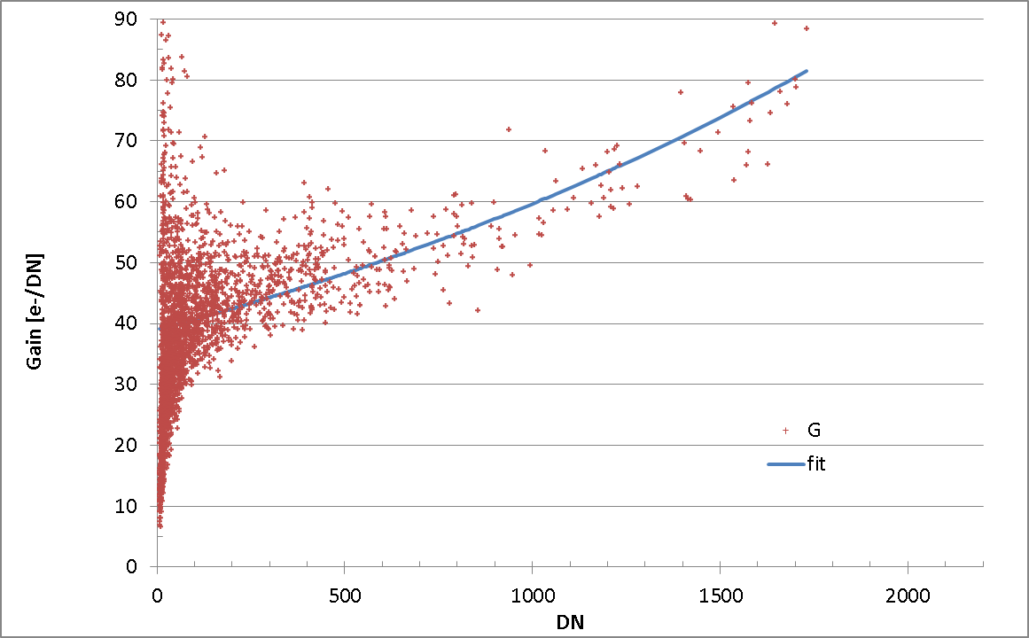

Figure 8. Determination of detector gain by photon transfer method, from image set 70.   
Red points are measured gain values; blue curve is least-squares fitted gain characteristic.

Results from image sets 70-79 are plotted in Fig. 11, where each measured $G$ value (red points) was obtained from a pair of commanded exposures. Image sets 70-79 consisted of 6580 image acquisitions (saturated images were removed), and it was selected for the photon transfer analysis because the temperature conditions during this portion of the altitude chamber test were the closest to those during flight.

The filter setting does not affect the photon transfer test, assuming that each filter produces a uniform illumination. There is no indication of separate characteristics in different filters. The average signal level detected, determined by target plate temperature and certain instrument temperatures (like window 1), needs to be varied for the photon transfer test, although it needs to be held stable during the time required to acquire the two images (four frames) for each $G$ value. Varying detector signal levels are achieved by using a range of exposure times in each image set. The instrument temperatures that affect detector characteristics are held as stable as possible throughout each image set, but target plate and Window 1 temperatures were slowly varying.

An analytic function is least-squares fitted to the measured $G$ values from image set 70:

$$G\left(DN\right)=E1*exp\left(-\frac{DN}{E2}\right)$$

$E1=$**38.957853; $E2=$ 2344.65846**

The gain *G*, in electrons per DN, is a non-linear function of DN. At 5 DN, the fitted gain $G$ is 39.0 e-/DN, and it increases to reach $G$ = 40.7 e-/DN at 100 DN. The gain increases more rapidly through the upper part of the dynamic range, reaching $G$ = 73.9 e-/DN at 1500 DN.

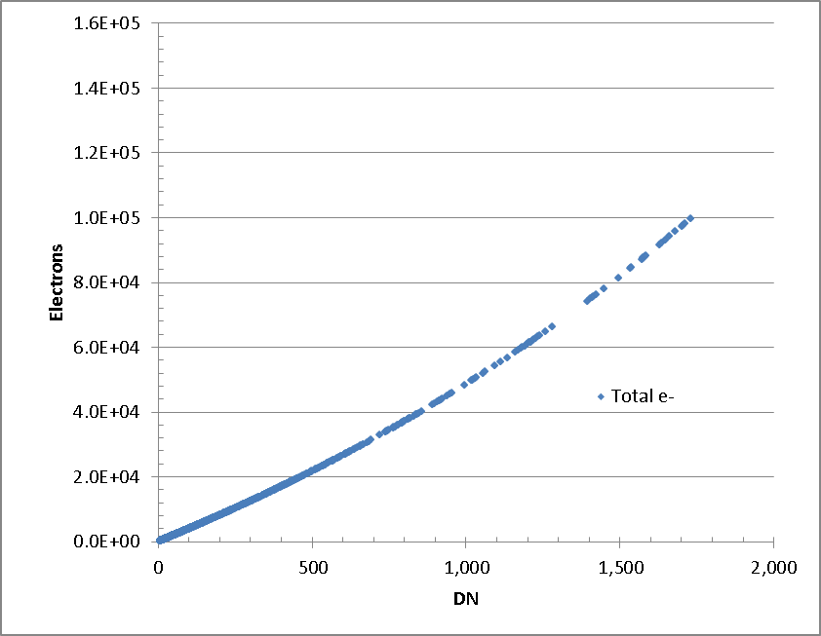

Figure 9. The cumulative number of photoelectrons detected versus DN

The conversion of DN in a pixel, to the number of photoelectrons counted, is obtained by integration of the function $G\left(DN\right)$ from zero to the measured DN. The analytic function $G\left(DN\right)$ is integrated to generate the cumulative number $S$ of photoelectrons detected versus DN, that is

$$S=91342.858*exp\left(-\frac{DN}{2344.65846}\right)-91342.858$$

which is the desired non-linear photon transfer characteristic. This function is plotted in Fig 12 giving the total detected photoelectrons $S$ versus DN.

A total of 1e5 photoelectrons has been detected at 1734 DN, for an average gain of 57.7 e-/DN. There does not appear to be a well-defined cut-off at full well, but the non-linearity is exponentially increasing, and the full well is placed nominally at 1e5 electrons.

The photon transfer analysis (see Appendix B) also yields the read noise of 1.52 ± 0.065 DN. However, at low DN the gain $G$ is about 39.0 e-/DN. The read noise is then about 59 electrons at low DN. At higher signal levels, the gain is also higher leading to higher read noise as expressed in electrons. For instance, at 250 DN of signal, the gain is 43.3 e-/DN and the read noise is 66 electrons.

The frequency histogram of read noise is shown in Fig. 13. This shows the number of points for which a given read noise value is determined from a single window in a pair of bias frames. The detector was well-behaved during this photon transfer test.

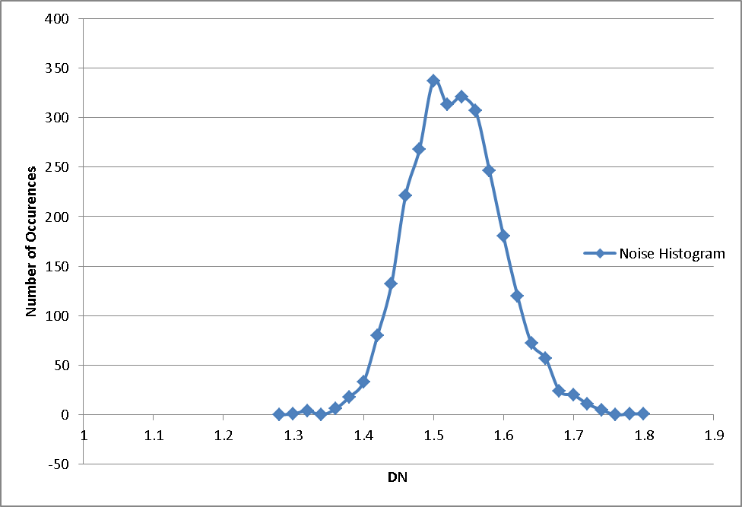

Figure 10. Read noise histogram. The read noise is 1.52 ± 0.065 DN

The photon transfer test also yields the measured SNR plotted in Fig. 14. The SNR at full well is about 350. This SNR includes read noise and shot noise, but not other noise contributions (see Appendix B).

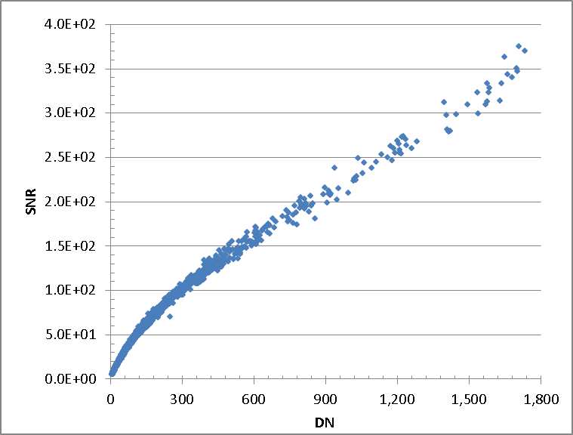

Figure 11. Signal-to-noise ratio SNR from photon transfer test, image set 70

**Appendix B Photon Transfer Test Background**

The fundamental model of image noise adopted here includes three noise sources: read noise, shot noise, and fixed pattern noise. These noise sources are independent and are added in quadrature. Read noise is independent of signal level, shot noise is proportional to the square root of signal, and fixed pattern noise is proportional to signal. These different dependences on signal level are used in a photon transfer test to separate the noise sources, by analyzing how the signal variances change with signal level A general reference is (Janesick, 2007).

Photon shot noise arises because for a steady illumination source, the arrival times of photons on the detector obey Poisson statistics. That is, the mean number of photons arriving on the detector per sec (the count rate ct/px/s) is the same as the variance of the ct/px/s. Hence the rms noise varies as the square root of the signal. On a log-log plot of shot noise versus signal, the shot noise plots as a line of slope ½. At low signal levels, the shot noise becomes small and is usually dominated by read noise which is independent of signal (see Fig 15, showing a photon transfer curve, plotting noise versus signal):



Figure 12. Generic photon transfer curve, a plot of noise versus signal.

If the fixed pattern noise is low enough, a distinct region appears in the photon transfer curve where shot noise dominates, and here the slope is ½. At higher signal levels, the fixed pattern noise often dominates the shot noise and produces another linear region with slope=1 (assuming the detector has not saturated yet). As signal increases further, the curve eventually turns over as the detector reaches full well and saturates.

However, such clearly defined regimes do not always appear for detectors depending on their relative levels of read noise and fixed pattern noise and on their saturation characteristics. In the more general case, the fundamental noise model is applied to find the detector gain, where the total rms noise is

$$σ_{TOTAL}={\left({σ_{READ}}^{2}+{σ_{SHOT}}^{2}+{σ_{FIXPATTERN}}^{2}\right)}^{1/2}$$

The photon transfer test applies this noise model to meet the following experimental objectives:

* Measure read noise
* Measure ADC gain, written $G$,in electrons/DN
* Estimate full well

The fixed pattern noise is not an objective of this test and is therefore removed as best we can. Typically this is accomplished by taking images in pairs under identical conditions (with identical signals, but two realizations of the noise sampled from the same distribution). The images of a pair are subtracted from each other, or their ratio is taken, to remove fixed pattern noise; both methods are commonly used. Differencing the image pairs will be used here.

Also as a prerequisite of the photon transfer test, it is necessary to identify the ‘bad’ pixels, meaning those whose DN values are abnormally high or abnormally low. The bad pixels should not be included.

The photon transfer test also requires that the pairs of images be taken with a constant, flat-field source at a variety of exposure levels, ranging from close to saturation level to less than 10% of saturation. At least several exposure levels, logarithmically spaced within that interval (the linear response region of the detector), are needed.

## Read Noise

The total *read noise $σ_{READ}$* in units of DN is measured using pairs of ‘bias frames’, which are taken with zero signal. For BIRC, we do not have true bias frames because the H2RG is not operated in any mode where there is zero exposure to foreground signal. The detector has masked rows and columns, and these (or portions of these) are returned with every frame, but the H2RG does not have detectors in its masked rows and columns, so they are not usable for bias frames.

Instead, we will use frames with the minimum possible exposure of 3.48 ms as bias frames. The H2RG is operated such that one of these minimum exposure image frames is acquired just before every commanded exposure frame, and both frames are stored. The commanded exposure frame is subtracted from the minimum exposure frame for bias correction and to invert the DN values such that larger DN indicates higher signal strength. The noise from these minimum exposure frames is effectively the read noise given how BIRC is operated, although it includes a small amount of dark current and thermal self-emission as well as foreground signal.

We then define ‘windows’ within pairs of minimum exposure bias frames taken under identical conditions. These windows avoid bad pixels or have bad pixels removed. Each window should have at least 400 px for good statistics. We will want to use the same windows for many pairs of frames.

The procedure follows:

1. Collect pairs of bias frames under identical conditions
2. Create a difference frame by subtracting one member from the other of the bias frame pair to remove fixed pattern noise
3. Identify windows avoiding (or removing) bad pixels. Calculate the standard deviation σ for each window and divide by $\sqrt{2}$ (because the noise is increased by $\sqrt{2}$ when differencing images)
4. Repeat for all windows and all pairs of frames
5. Produce a histogram of σ/ $\sqrt{2}$ values. The mean value of σ/ $\sqrt{2}$ (or the median, if the noise distribution is non-standard) estimates the read noise $σ_{READ}.$ The error of the mean is the standard deviation of the σ/ $\sqrt{2}$ values divided by $\sqrt{N}$, where ***N*** is the number of σ values.

## ADC Gain

The *gain $G$* in electrons/DNrefers to the proportionality constant between DN (or counts) and electrons. The fundamental noise model now gives the total noise variance (in electrons) as

$${δn}^{2}=σ_{e}^{2}+n$$

Where $σ_{e}$ is the read noise in electrons, related to $σ_{READ}$ by the gain, $σ_{e}=Gσ_{READ}$, and where the second term is the mean number of electrons which is also the variance from shot noise. We neglect fixed pattern noise. Both sides of this equation are divided by $G^{2}$ to obtain

$${δS}^{2}=σ_{READ}^{2}+\frac{S}{G}$$

Here S is the mean observed signal in DN, related to *n* by *S = Gn*, and ${δS}^{2}$ is the total variance in the observed signal (expressed in DN2). The read noise squared (also in DN2) was determined in the previous step. The gain is then

$$G=\frac{S}{{δS}^{2}-{σ_{READ}}^{2}}$$

Now we identify windows (avoiding or removing bad pixels) in the illuminated areas of the frames. We find pairs of (bias-subtracted) frames under identical flat-field illumination, with exposure levels in the linear regime. The following steps determine the gain from each pair:

1. Create a difference frame by subtracting one image from the other. Create an average frame by averaging the two images.
2. Within each window, calculate the average DN value from the average frame to obtain *S*.
3. Within each window, calculate the standard deviation of the DN from the difference frame and divide the result by $\sqrt{2}$. Then square to find ${δS}^{2}$.
4. Form $G$ using the formula given above.
5. Form histogram from all windows in all pairs of images.
6. The average gain is the mean of the $G$ values, and the standard error in the gain is the standard deviation of the $G$ values divided by the square root of the number of $G$ values.
7. Form a plot of variance ${δS}^{2}$ versus signal *S*.

## SNR

The signal-to-noise ratio, including read noise and shot noise, is determined by $S/{δS}$

$$SNR=\frac{S}{\sqrt{σ_{read}^{2}+S/G}}$$